SMARTFLOW SUPPLY CHAIN SYSTEM
A PROJECT REPORT
Submitted by
NAVEEN ST
240701351
in partial fulfilment of the End Semester Examination for the course
CB23F35 –
LOW-CODE APPLICATION DEVELOPMENT USING ZOHO CREATOR
in
BACHELOR OF ENGINEERING
COMPUTER SCIENCE AND ENGINEERING

RAJALAKSHMI ENGINEERING COLLEGE
(An Autonomous Institution, Affiliated to Anna University, Chennai)
Rajalakshmi Nagar, Thandalam, Tamil Nadu – 602 105
NOVEMBER 2026

RAJALAKSHMI ENGINEERING COLLEGE
(An Autonomous Institution, Affiliated to Anna University, Chennai)
BONAFIDE CERTIFICATE
Certified that this project report titled “SmartFlow Supply Chain System” is the bonafide work Naveen ST (240701351), who carried out the individual project work on the Zoho Creator low-code platform for the course CB23F35 – Low-Code Application Development using Zoho Creator, during the academic year [2026–2027], Semester [ V ], under my supervision.
SIGNATURE  Dr. J MANORANJINI ALWIN  HEAD OF THE DEPARTMENT  Department of Computer Science and Engineering  Rajalakshmi Engineering College  Thandalam – 602 105 | SIGNATURE  Dr. J. JINU SOPHIA  COURSE FACULTY  Assistant Professor (SG)  Department of Computer Science and Engineering  Rajalakshmi Engineering College

Submitted for the End Semester Examination (Individual Project) held on 11th November 2026.
INTERNAL EXAMINER | EXTERNAL EXAMINER

DECLARATION
I, Naveen ST (240701351), hereby declare that the project report titled “SmartFlow Supply Chain System”, submitted for the End Semester Examination of the course CB23F35 – Low-Code Application Development using Zoho Creator, is a record of original work carried out by me individually. The Zoho Creator application described in this report — including its data model, forms, reports, pages, Deluge scripts, workflows and integrations — was designed and developed by me.
I further declare that this work has not been submitted, in part or in full, for the award of any other degree or course credit. Every template, sample application, AI-assisted feature (such as Zia or the AI application builder), code snippet or external resource used in this work has been duly acknowledged in the report.
Place: Chennai SIGNATURE OF THE STUDENT
Date: 1111/2026 Naveen ST
240701351
ACKNOWLEDGEMENT
I express my sincere gratitude to our Chairman Thiru S. Meganathan, Chairperson (Mrs.) Thangam Meganathan and Vice-Chairman Mr. Abhay Shankar Meganathan for providing the infrastructure and facilities that made this work possible.
I am grateful to our Principal, Dr. S. N. Murugesan, Rajalakshmi Engineering College, for the constant encouragement extended to students to take up industry-relevant learning.
I thank Dr. Manoranjini Alwin, Head of the Department, Department of Computer Science and Engineering, for the guidance and support provided throughout the course.
I owe my sincere thanks to my course faculty, Dr. J. Jinu Sophia, Assistant Professor (SG), for the valuable guidance, reviews and feedback that shaped this application and report.

I also acknowledge Zoho Corporation for providing access to the Zoho Creator platform, its Zia AI features and its learning resources, and I thank my family and friends for their unwavering support.

NAVEEN ST

ABSTRACT
Distribution businesses depend on accurate, up-to-date knowledge of what stock is available, what has been ordered from suppliers and which customer orders are waiting for delivery. In many small and medium enterprises this information is scattered across notebooks, spreadsheets, telephone calls and messaging applications. The result is stock-outs that are noticed too late, repeated data entry, delayed reordering and no clear view of deliveries.
This project presents SmartFlow Supply Chain System, an application built on the Zoho Creator low-code platform for a Chennai-based distribution company. The data model consists of twelve linked forms covering suppliers, customers, products, warehouses, inventories, purchase orders and their items, goods receipts and their items, customer orders and their items, and shipments. Deluge scripts and workflows add stock automatically when a purchase order is received, deduct stock when a shipment is delivered, calculate stock status, and e-mail the warehouse manager when stock falls below the safety level or reaches zero. Further workflows send goods-receipt notifications and a scheduled inventory report. Zia AI is used for sentiment analysis of goods-receipt discrepancy notes and for an OCR model for supplier invoices, new customers are synchronised to Zoho CRM through an OAuth connection, and role-based permissions give each of the four user roles access only to the forms it needs.
The application was tested with eighteen test cases, eight defects found during development were analysed and fixed, and the application is deployed through the Development, Stage and Production environments for four users. The automation removes four recurring manual steps: updating the stock register after each receipt, updating it after each delivery, checking stock levels against the reorder point, and re-entering customers in a separate CRM. The warehouse manager is notified at the moment a stock level becomes critical instead of discovering it later.
Keywords: Low-Code Development; Zoho Creator; Deluge Scripting; Workflow Automation; Role-Based Access Control; Supply Chain Management

PROJECT AT A GLANCE
Attribute | Details
Project Title | SmartFlow Supply Chain System
Application Domain | Supply Chain and Logistics (distribution and warehousing)
Student Name & Register No. | Naveen ST – 240701351
Zoho Creator Edition | Zoho Creator Free Trial Edition
Application Name (Link Name) | SmartFlow Supply Chain System (smartflow-supply-chain-system1)
Published / Live URL | https://creatorapp.zoho.in/naveen.st.2024.cse_rajala260/smartflow-supply-chain-system
Demo Credentials (per role) | Admin: naveen.st.2024.cse@rajalakshmi.edu.in
Number of Forms / Subforms | 12 / 0 (line items are held in separate item forms linked by lookup)
Number of Reports (by type) | List: 12 (one per form), Kanban: 8
Number of Pages / Dashboards | 1 (Dashboard)
Number of Workflows | Form: 15 Schedule: 5
Deluge Functions / Custom Actions | 2 functions (getReceiptNotes, saveReceiptSentiment)
Integrations | Zoho CRM (OAuth connection); e-mail service (sendmail); Zia AI models (sentiment, OCR)
Roles & Profiles Defined | Administrator, Procurement Manager, Warehouse Manager, Sales Executive
Environments Used | Development → Stage → Production
Date of Production Deployment | 08/11/2026

TABLE OF CONTENTS
ABSTRACT iv
PROJECT AT A GLANCE v
LIST OF TABLES ix
LIST OF FIGURES x
LIST OF ABBREVIATIONS xi
INTRODUCTION 1
1.1 Background 1
1.2 Problem Statement 1
1.3 Objectives 2
1.4 Scope of the Project 2
1.5 Justification for a Low-Code Approach 3
1.6 Organisation of the Report 3
LITERATURE SURVEY AND SYSTEM STUDY 4
2.1 Study of the Existing System 4
2.2 Limitations of the Existing System 4
2.3 Low-Code versus Traditional Development 5
2.4 Literature Survey 5
2.5 Emerging Trends in Low-Code Development 6
2.6 Proposed System 7
REQUIREMENT ANALYSIS 8
3.1 Stakeholders and User Roles 8
3.2 Functional Requirements 8
3.3 Non-Functional Requirements 9
3.4 Hardware and Software Requirements 10
3.5 Use Case Model 10
SYSTEM DESIGN 12
4.1 System Architecture 12
4.2 Data Model 13
4.3 Form Design 14
4.4 Process and Workflow Design 16
4.5 User Interface and Navigation Design 16
4.6 Access Control Design 17
IMPLEMENTATION 18
5.1 Application Setup 18
5.2 Forms and Data Capture 19
5.3 Reports 21
5.4 Pages and Dashboards 22
5.5 Deluge Scripting 22
5.6 Workflows and Automation 24
5.7 Integrations 25
5.8 User Management and Role-Based Access 26
5.9 AI and Analytics Features 27
5.10 Pro-Code Extension 28
5.11 Mobile and Portal Access 28
TESTING AND DEBUGGING 29
6.1 Testing Strategy 29
6.2 Test Cases 29
6.3 Debugging Deluge Scripts 30
6.4 Defect Log 31
6.5 User Acceptance Testing 31
DEPLOYMENT, SECURITY AND GOVERNANCE 32
7.1 Environments and Deployment Strategy 32
7.2 Performance Optimisation 33
7.3 Security Features 33
7.4 Governance and Administration 34
RESULTS AND DISCUSSION 35
8.1 Application Output 35
8.2 Achievement of Objectives 36
8.3 Comparison with the Existing System 36
8.4 Limitations of the Low-Code Approach 37
8.5 Reflection on the No-Code → Low-Code → Pro-Code Spectrum 37
CONCLUSION AND FUTURE ENHANCEMENTS 38
9.1 Conclusion 38
9.2 Future Enhancements 38
9.3 Learning Outcomes and Career Relevance 38
REFERENCES 39
APPENDIX A – ZOHO CREATOR FEATURE COVERAGE CHECKLIST 40
APPENDIX B – COURSE OUTCOME MAPPING 42
APPENDIX C – COMPLETE DELUGE SOURCE CODE 43
APPENDIX D – USER MANUAL 46
D.1 Accessing the Application 46
D.2 Instructions for the Administrator 46
D.3 Instructions for the Procurement Manager 46
D.4 Instructions for the Warehouse Manager 46
D.5 Instructions for the Sales Executive 46
APPENDIX E – EVALUATION RUBRIC 47
APPENDIX F – VIVA-VOCE RECORD SHEET 49

LIST OF TABLES
Table 2.1: Comparison of Low-Code and Traditional Development for the Proposed Application 5
Table 2.2: Summary of Literature Survey 6
Table 3.1: Stakeholders and User Roles 8
Table 3.2: Functional Requirements 8
Table 3.3: Non-Functional Requirements 9
Table 3.4: Hardware and Software Requirements 10
Table 3.5: Use Case Description – Receive Purchase Order and Update Stock 10
Table 3.6: Use Case Description – Deliver Shipment and Raise Stock Alert 11
Table 3.7: Use Case Description – Review Goods Receipt with AI Sentiment 11
Table 4.1: Entities and Relationships 13
Table 4.2: Field Specification – Suppliers Form 14
Table 4.5: Field Specification – Warehouses Form 15
Table 4.9: Field Specification – Goods Receipts Form 15
Table 4.14: Role–Permission Matrix 17
Table 5.1: Reports Implemented 21
Table 5.2: Deluge Scripts Developed 23
Table 5.3: Workflows Implemented 25
Table 5.4: Integrations Implemented 25
Table 5.5: AI and Analytics Features 27
Table 6.1: Test Cases and Results 29
Table 6.2: Defect Log 31
Table 6.3: User Acceptance Testing Feedback 31
Table 7.1: Deployment Checklist 32
Table 7.2: Performance Optimisations Applied 33
Table 7.3: Security Controls 33
Table 8.1: Achievement of Objectives 36
Table 8.2: Existing System versus SmartFlow 36
Table A.1: Feature Coverage Checklist 40
Table B.1: Mapping of Course Outcomes to Report Chapters 42
Table E.1: Evaluation Rubric for the Individual Project 47
Table E.2: Performance Level Descriptors 48
Table F.1: Viva-Voce Questions and Responses 49
Table F.2: Marks Summary 49

LIST OF FIGURES
Figure 2.1: As-Is Process Flow of the Existing System 4
Figure 3.1: Use Case Diagram of the Application 10
Figure 4.1: System Architecture of the Application 12
Figure 4.2: Entity–Relationship Diagram 13
Figure 4.3: Workflow / Process Flow for Stock Update and Alerting 16
Figure 4.4: Navigation Structure of the Application 17
Figure 5.1: Application Navigation and the Warehouses Form in Live Mode 18
Figure 5.2: Suppliers Form (Live Mode) 19
Figure 5.3: Customers Form (Live Mode) 20
Figure 5.4: Products Form (Live Mode) 20
Figure 5.5: Customer Orders Form (Live Mode) 20
Figure 5.6: All Inventories Report Showing Quantity on Hand, Reserved, Available, Safety Stock and Stock Status 22
Figure 5.7: Dashboard Page of the Application 22
Figure 5.8: Zoho CRM Contacts Module 26
Figure 5.9: Role Profiles and Restricted User View 26
Figure 5.10: Goods Receipt Record with the AI Sentiment Result 28
Figure 6.1: Script Editor Error: Form alert_logs Does Not Exist 30
Figure 6.2: Script Editor Error: Invalid Collection Object Found 30
Figure 7.1: Deployment Across Environments 32
Figure 7.2: Administration and Audit Trail 34
Figure 8.1: Daily Inventory 35
Figure 8.2: Inventories Report Showing Product-Wise Stock in Chennai_main 35
Figure 8.3: Low Stock Alert E-mail 36

LIST OF ABBREVIATIONS
Abbreviation | Expansion
AI | Artificial Intelligence
API | Application Programming Interface
CRM | Customer Relationship Management
CRUD | Create, Read, Update, Delete
ER | Entity–Relationship
FR | Functional Requirement
GR | Goods Receipt
JSON | JavaScript Object Notation
KPI | Key Performance Indicator
LCAP | Low-Code Application Platform
NFR | Non-Functional Requirement
OAuth | Open Authorization
OCR | Optical Character Recognition
PO | Purchase Order
RBAC | Role-Based Access Control
REST | Representational State Transfer
SCM | Supply Chain Management
SKU | Stock Keeping Unit
UAT | User Acceptance Testing
UI | User Interface
Zia | Zoho’s AI assistant

CHAPTER 1

INTRODUCTION

1.1 Background
Supply chain management (SCM) covers the planning and coordination of everything that happens between buying goods from a supplier and delivering them to a customer: procurement, storage, order fulfilment and transport [1]. For a distribution business the most important figure at any moment is the quantity of each product that is physically available and not yet promised to a customer. If this figure is wrong, the business either runs out of stock and loses sales, or over-orders and ties up money.
The organisation considered in this project is SmartFlow Distribution, a realistic mid-sized distributor in Chennai. It buys packaging material, electronic accessories and appliances from several suppliers, stores them in a warehouse, sells them to retail shops and delivers them with its own delivery agents. Four groups of people are involved: the owner or administrator, a procurement manager who deals with suppliers, a warehouse manager who receives goods and keeps the stock correct, and a sales executive who takes customer orders and arranges delivery.
Today the business runs on notebooks, spreadsheets, telephone calls and messaging applications. A stock figure is updated by hand after every receipt and every delivery, a purchase request is sent to a supplier by telephone or e-mail, and the customer is told about a delivery by a phone call. Each of these hand-offs is an opportunity for an error or a delay.

1.2 Problem Statement
The business has no single, reliable system in which stock, purchases, sales and deliveries are connected. Information is entered more than once, stock levels are checked only when someone remembers to do so, and nobody is alerted when a product is about to run out. A low-code application is needed that records every purchase, receipt, sale and shipment once, updates stock automatically from those events, and warns the responsible person at the right time. The specific pain points are:
- Stock registers are updated manually after every goods receipt and every delivery, so figures are often out of date.
- Low stock is noticed only after a customer order cannot be fulfilled, because no one is alerted when stock crosses the safety level.
- The same supplier, customer and product details are typed repeatedly in different files and in the customer relationship tool.
- Problems found while receiving goods (damaged or late consignments) are recorded on paper and do not reach the procurement manager quickly.
- Different employees can see or change information that is not part of their job, because there is no role-based access.

1.3 Objectives
- To design a normalised data model and twelve linked forms for suppliers, customers, products, warehouses, inventory, purchasing, goods receipt, sales and shipment records.
- To automate stock updates, low-stock and out-of-stock alerts, goods-receipt notifications and inventory reporting using Deluge scripting and workflows.
- To provide list reports and a dashboard so that managers can see stock, orders and shipment status at a glance.
- To integrate the application with Zoho CRM for customer synchronisation and to apply Zia AI (sentiment analysis and OCR) to goods-receipt notes and supplier invoices.
- To implement role-based access for four user roles so that each user sees only the forms and reports needed for the job.
- To deploy the application securely to a production environment for four users with governance controls.

1.4 Scope of the Project
In scope: web-based application on Zoho Creator, also usable through the Zoho Creator mobile app; twelve data forms with lookups; list reports; one dashboard page; form workflows and scheduled workflows written in Deluge; e-mail alerts; Zia sentiment analysis and OCR; integration with Zoho CRM; four internal user roles (Administrator, Procurement Manager, Warehouse Manager, Sales Executive); and deployment through Development, Stage and Production environments.
Out of scope: a public customer or supplier portal, online payment, GPS tracking of vehicles, accounting and invoicing, and multi-currency or multi-company operation. These are listed as future enhancements in Section 9.2.

1.5 Justification for a Low-Code Approach
A low-code platform lets a small team build a working business application by configuring forms, reports and workflows visually and writing code only where the logic requires it [2]. Industry analysts treat low-code application platforms as a mainstream way to deliver business applications faster than conventional development [3]. Zoho Creator was chosen because it provides hosting, a built-in database, role-based security, e-mail, mobile access and AI features in a single platform, and it supports the Deluge scripting language for custom logic [4].
For SmartFlow the main advantages are speed (the data model and forms were generated from a prompt and then refined), maintainability (a field or a workflow can be changed by a citizen developer without redeploying a server), built-in security through roles and profiles, and low cost (no separate hosting, database or mobile application had to be purchased or developed).

1.6 Organisation of the Report
Chapter 2 reviews the existing system and related low-code literature. Chapter 3 presents the requirement analysis. Chapter 4 describes the system design. Chapter 5 details the implementation on Zoho Creator. Chapter 6 covers testing and debugging. Chapter 7 discusses deployment, performance optimisation, security and governance. Chapter 8 presents results and discussion, and Chapter 9 concludes the report with future enhancements.
CHAPTER 2

LITERATURE SURVEY AND SYSTEM STUDY

2.1 Study of the Existing System
In the existing system the buying side and the selling side are run separately and by hand. Stock is counted physically and written in a spreadsheet. When a product seems to be running low, the procurement manager sends a request to a supplier by telephone or e-mail. When the goods arrive, the warehouse keeper checks them against a paper delivery note and updates the spreadsheet. On the selling side, a customer places an order by telephone or messaging application, the order is noted in a notebook or spreadsheet, the delivery is arranged by telephone and the customer is informed manually. Stock figures have to be re-checked by hand before an order can be promised. Figure 2.1 shows this flow.

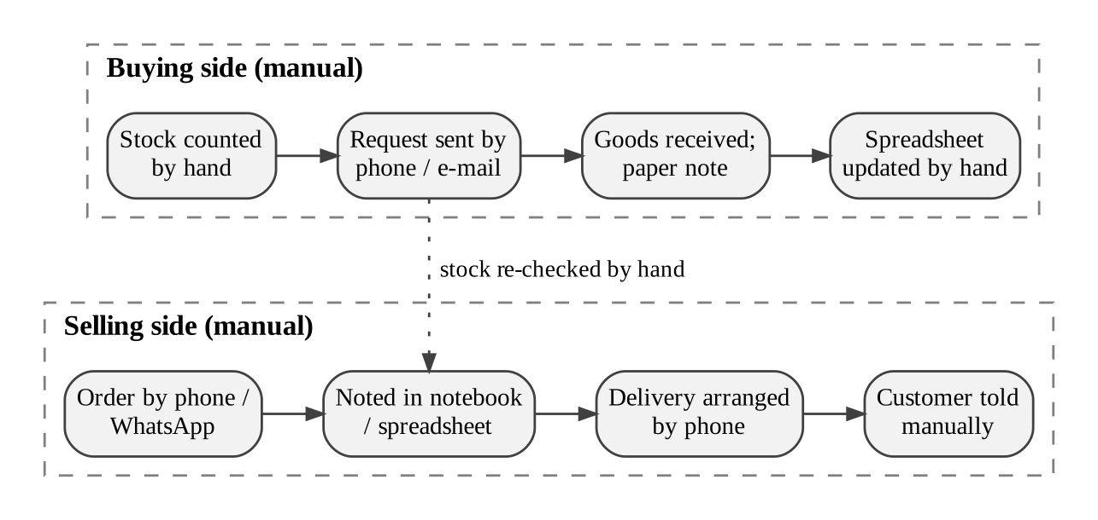
Figure 2.1: As-Is Process Flow of the Existing System

2.2 Limitations of the Existing System
- Stock figures depend on manual updates after every receipt and delivery and are frequently wrong.
- No automatic alert is raised when stock falls below the safety level or reaches zero.
- The same supplier, customer and product data is entered in more than one place.
- Quality problems found at goods receipt are not escalated to the procurement manager in time.
- There is no role-based access, no audit trail and no consolidated report or dashboard.

2.3 Low-Code versus Traditional Development
Table 2.1 compares the two approaches for the SmartFlow application. The effort figures are estimates made by the author for an application of this size.
Table 2.1: Comparison of Low-Code and Traditional Development for the Proposed Application
Criterion | Traditional (Pro-Code) Development | Low-Code on Zoho Creator
Development time | Estimated 10–12 weeks for database design, back end, front end, and testing | Estimated 3–4 weeks for design, forms, workflows, and testing
Skills required | Database design, a back-end language, a front-end framework, e-mail and hosting set-up | Data modelling, form design and basic Deluge scripting
Hosting & infrastructure | Server, database and domain must be purchased, installed and maintained | Hosted by Zoho; no server administration
Mobile application | Separate mobile application or responsive front end must be developed | Available through the Zoho Creator mobile app without extra development
Security & access control | Login, roles and permissions must be coded and tested | Built-in roles, profiles, form- and report-level permissions
Maintenance & change | Code change, test and redeploy for every new field or rule | Change a field or workflow in the builder; publish through environments
Customisation limits | Almost unlimited | Limited by platform features, field types and Deluge statement limits
Cost | Developer salaries, hosting and licences | Creator subscription per user; no separate hosting cost

2.4 Literature Survey
Eight sources were reviewed: a textbook on supply chains, research papers on low-code platforms, analyst research, and the vendor documentation of the platform used. Table 2.2 summarises them and their relevance to this project.
Table 2.2: Summary of Literature Survey
S.No. | Author(s) / Source & Year | Title / Product | Key Findings | Relevance to this Project
1 | S. Chopra and P. Meindl, 2019 [1] | Supply Chain Management: Strategy, Planning, and Operation | Describes the supply chain as the flow of goods, information and funds between suppliers, warehouses and customers, and stresses inventory visibility and responsiveness. | Defines the domain model: suppliers, inventory, orders and shipments.
2 | A. C. Bock and U. Frank, 2021 [2] | Low-Code Platform | Characterises low-code platforms by visual modelling, abstraction and rapid application delivery, and discusses their limits. | Supports the choice of a low-code approach and the discussion of limits.
3 | Gartner, Inc., 2023 [3] | Magic Quadrant for Enterprise Low-Code Application Platforms | Evaluates low-code platforms on application development, automation and governance capabilities. | Shows that low-code platforms are accepted in enterprises.
4 | Zoho Corporation [4] | Zoho Creator Help Documentation | Documents forms, reports, pages, workflows, connections, roles and AI features. | Primary reference for the implementation.
5 | Zoho Corporation [5] | Deluge Script Reference Guide | Explains Deluge syntax, data-access tasks, sendmail and integration tasks. | Reference for all scripts in Appendix C.
6 | W. Rosam and O. Kalnichevski [6] | Low-Code Development: A Practical Guide | Course text covering low-code concepts, platforms and development practice. | Concept base for Chapters 1 and 2.
7 | A. Sahay, A. Indamutsa, D. Di Ruscio and A. Pierantonio, 2020 [7] | Supporting the understanding and comparison of low-code development platforms | Compares low-code platforms on a common feature framework. | Guides platform comparison and feature checklist.
8 | R. Waszkowski, 2019 [8] | Low-code platform for automating business processes in manufacturing | Reports a case study in which a low-code platform automated business processes in a manufacturing company. | A comparable case of process automation.
9 | K. Rokis and M. Kirikova, 2022 [9] | Challenges of Low-Code/No-Code Software Development: A Literature Review | Reviews challenges such as customisation limits, vendor lock-in and governance. | Basis for Section 8.4 on limitations.

2.5 Emerging Trends in Low-Code Development
Four trends are relevant to this application. The first is AI-assisted application building: Zoho’s Zia builder can create forms, fields and relationships from a text prompt, and SmartFlow’s initial structure was created in this way and then refined by hand. The second is citizen development: business users such as a warehouse manager can adjust fields and reports without a programmer, which shaped the decision to keep helper fields simple and visible in the builder. The third is hyper-automation, the combination of workflows, scripts, AI and integrations to remove manual steps; SmartFlow applies it to stock updates, alerts, sentiment analysis and CRM synchronisation. The fourth is composable applications, in which an application is assembled from services; SmartFlow reuses Zoho CRM and the e-mail service instead of building them. Research also warns about governance, vendor lock-in and customisation limits [9], which are discussed in Section 8.4.

2.6 Proposed System
The proposed system is a Zoho Creator application in which every purchase, receipt, sale and shipment is recorded once in linked forms. A Purchase Order marked Received adds stock automatically; a Shipment marked Delivered removes it; and alerts reach the warehouse manager when stock is low or exhausted. Each limitation in Section 2.2 is addressed in turn: manual stock updates are replaced by workflows, alerts are generated automatically, master data is entered once and synchronised to Zoho CRM, goods-receipt problems are classified by Zia and e-mailed, and role-based permissions, record history and a dashboard provide access control, an audit trail and reporting.
CHAPTER 3

REQUIREMENT ANALYSIS

3.1 Stakeholders and User Roles
Table 3.1: Stakeholders and User Roles
Role | Description | Key Responsibilities in the Application
Administrator | Owner of the business and application administrator | Manage users and permissions, maintain master data, view all reports and the dashboard
Procurement Manager | Deals with suppliers and purchasing | Maintain suppliers and products, raise purchase orders, mark them Received, review goods-receipt alerts and invoice data
Warehouse Manager | Receives goods and keeps stock correct | Record goods receipts and receipt items, maintain inventories and warehouses, receive low-stock and out-of-stock alerts
Sales Executive | Takes customer orders and arranges delivery | Register customers, create customer orders and items, create shipments and mark them Delivered

3.2 Functional Requirements
Table 3.2: Functional Requirements
FR ID | Requirement | Role(s) | Priority
FR-01 | The system shall allow users to maintain supplier, customer, product and warehouse records with mandatory fields. | Admin, Procurement, Sales | High
FR-02 | The system shall maintain stock per product per warehouse and calculate Available Quantity as Quantity on Hand minus Reserved Quantity. | Warehouse Manager | High
FR-03 | The system shall allow a purchase order and its items to be created for a supplier and a delivery warehouse. | Procurement Manager | High
FR-04 | When a purchase order is marked Received, the system shall add the item quantities to inventory once only and e-mail a stock summary. | System | High
FR-05 | The system shall record goods receipts and receipt items (received, accepted, rejected) and e-mail the receipt details to the warehouse manager. | Warehouse Manager | Medium
FR-06 | The system shall classify goods-receipt discrepancy notes as Positive, Neutral or Negative using Zia and alert the procurement manager on Negative. | System | Medium
FR-07 | The system shall extract the invoice number, date and total from a supplier invoice using an OCR model. | Procurement Manager | Medium
FR-08 | The system shall allow a customer order and its items to be created, with line total calculated from quantity and price. | Sales Executive | High
FR-09 | The system shall allow a shipment to be created for a customer order and its status to be tracked. | Sales Executive | High
FR-10 | When a shipment is marked Delivered, the system shall deduct the ordered quantity from inventory once only and update Stock Status. | System | High
FR-11 | The system shall e-mail the warehouse manager when Available Quantity falls below Safety Stock or reaches zero. | System | High
FR-12 | The system shall e-mail a daily inventory report on a schedule. | System | Medium

3.3 Non-Functional Requirements
Table 3.3: Non-Functional Requirements
NFR ID | Category | Requirement
NFR-01 | Performance | List reports with up to 1,000 records shall load within 5 seconds
NFR-02 | Security | Users shall access only the data permitted by their role
NFR-03 | Usability | The application shall be usable on the web and in the Zoho Creator mobile app
NFR-04 | Availability | The application shall be available whenever the Zoho Creator cloud service is available
NFR-05 | Maintainability | Fields, workflows and scripts shall be changeable in the builder without redeploying any server
NFR-06 | Auditability | All record changes shall be traceable through the audit trail

3.4 Hardware and Software Requirements
Table 3.4: Hardware and Software Requirements
Category | Specification
Platform | Zoho Creator Free Trial Edition
Scripting language | Deluge (Data Enriched Language for the Universal Grid Environment)
Browser | Google Chrome / Microsoft Edge / Mozilla Firefox (latest version)
Other Zoho services | Zoho CRM, Zia AI (sentiment analysis, OCR, AI agent)
Mobile | Zoho Creator mobile app (Android / iOS) for field users
Client hardware | Intel Core i3/i5 or above, 8 GB RAM, internet connection

3.5 Use Case Model
Figure 3.1 shows the use cases of the four roles and the external Zoho CRM system. Three key use cases are described in Table 3.5, Table 3.6 and Table 3.7.
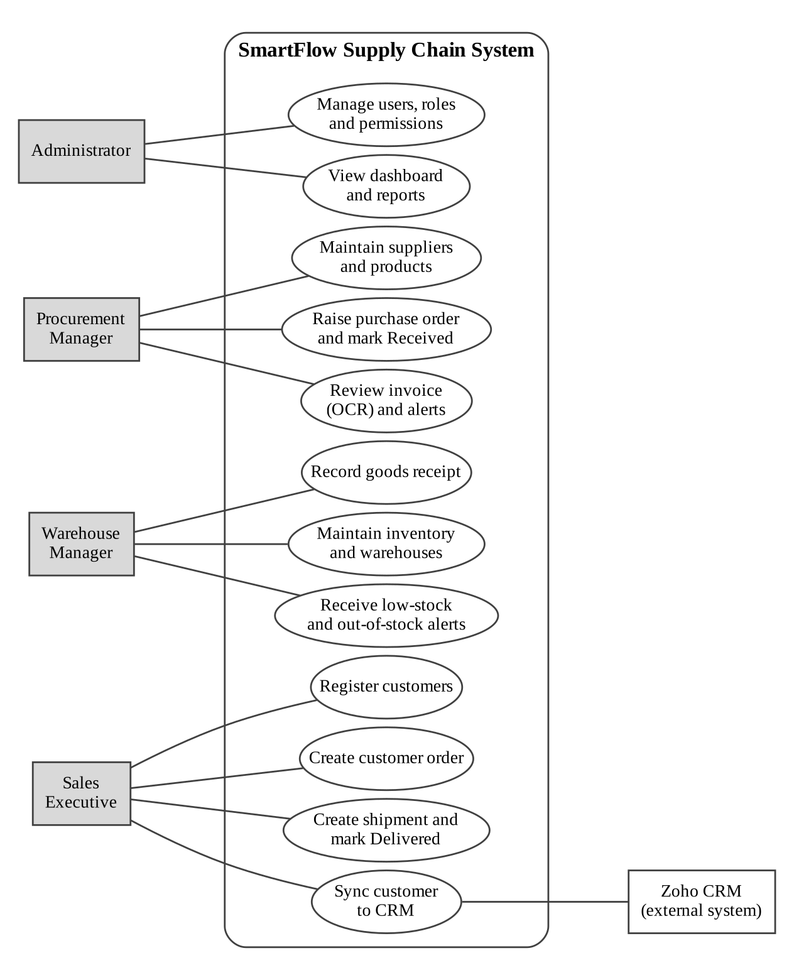
Figure 3.1: Use Case Diagram of the Application
Table 3.5: Use Case Description – Receive Purchase Order and Update Stock
Use Case ID | UC-01
Use Case Name | Receive Purchase Order and Update Stock
Actor(s) | Procurement Manager, Warehouse Manager
Pre-condition | A purchase order with at least one item exists and its status is Approved.
Main Flow | 1. The user opens the purchase order.  2. The user changes Purchase Order Status to Received and saves.  3. The workflow fetches the Purchase Order Items.  4. For each item the quantity is added to the matching inventory record, or a new record is created.  5. Stock Status is recalculated and a summary e-mail is sent.
Alternate Flow | If every item was already counted, nothing is added (the Qty Added To Stock counter equals the ordered quantity).
Post-condition | Inventory reflects the received goods; each item is counted only once.
Related FR | FR-03, FR-04

Table 3.6: Use Case Description – Deliver Shipment and Raise Stock Alert
Use Case ID | UC-02
Use Case Name | Deliver Shipment and Raise Stock Alert
Actor(s) | Sales Executive, Warehouse Manager
Pre-condition | A customer order with items and a shipment in In Transit status exist; matching inventory exists.
Main Flow | 1. The user opens the shipment and sets Shipment Status to Delivered.  2. The workflow fetches the Customer Order Items.  3. For each item the quantity is deducted from the matching inventory record and Stock Status is recalculated.  4. If Available Quantity is below Safety Stock, an e-mail is sent to the warehouse manager.  5. The Stock Deducted flag is ticked.
Alternate Flow | If Stock Deducted is already ticked, the script skips the deduction.
Post-condition | Stock is reduced once; the warehouse manager is alerted if stock is low or zero.
Related FR | FR-10, FR-11

Table 3.7: Use Case Description – Review Goods Receipt with AI Sentiment
Use Case ID | UC-03
Use Case Name | Review Goods Receipt with AI Sentiment
Actor(s) | Warehouse Manager, Procurement Manager
Pre-condition | A purchase order exists and goods have arrived.
Main Flow | 1. Zia classifies the notes into the Sentiment field and sent emails  2. The procurement manager contacts the supplier if the sentiment is Negative.
Alternate Flow | If the notes are empty, the sentiment is neutral and no action is needed.
Post-condition | Problem deliveries are reported to the right person on the same day.
Related FR | FR-05, FR-06
CHAPTER 4

SYSTEM DESIGN

4.1 System Architecture
Figure 4.1 shows the layered architecture. Layer 1 holds the four user roles, who reach the application through a web browser or the Zoho Creator mobile app. Layer 2 is the Zoho Creator application itself: forms for data capture, list reports, a dashboard page, workflows that react to form events and schedules, Deluge scripts and functions that hold the business logic, and Zia AI features. Layer 3 is the Zoho Creator cloud data store, which holds the form records and their lookups and keeps the audit trail. Layer 4 contains the integrations and services the application calls: Zoho CRM through an OAuth connection, the e-mail service through the sendmail task, and the Zia AI models for OCR and sentiment analysis.
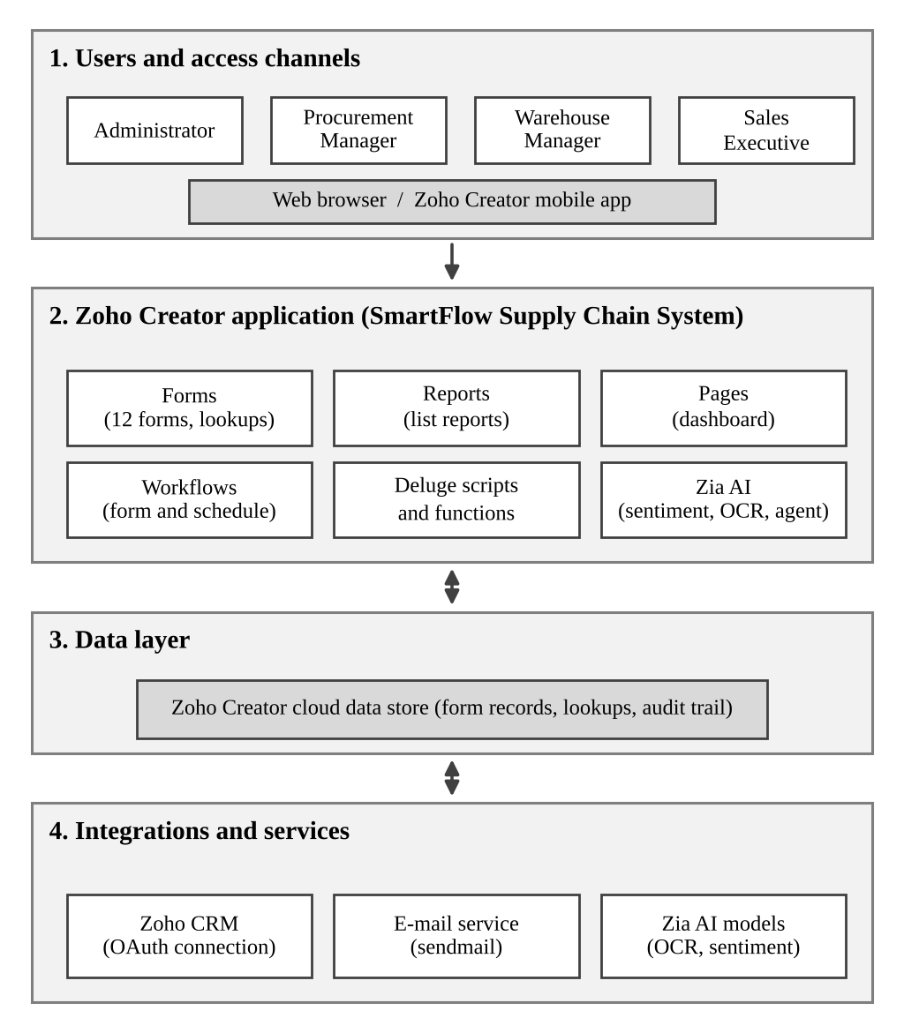
Figure 4.1: System Architecture of the Application

4.2 Data Model
The data model has twelve forms. In Zoho Creator, a one-to-many relationship is realised with a lookup field in the “many” form that points to the “one” form. Figure 4.2 shows the entity–relationship diagram and Table 4.1 lists the entities and their relationships. Line items are held in separate item forms (Purchase Order Items, Goods Receipt Items and Customer Order Items) that look up their parent record, instead of subforms. This keeps each line item as an independent record that scripts can fetch, filter and update, and it allows a helper field such as Qty Added To Stock to be stored per line.
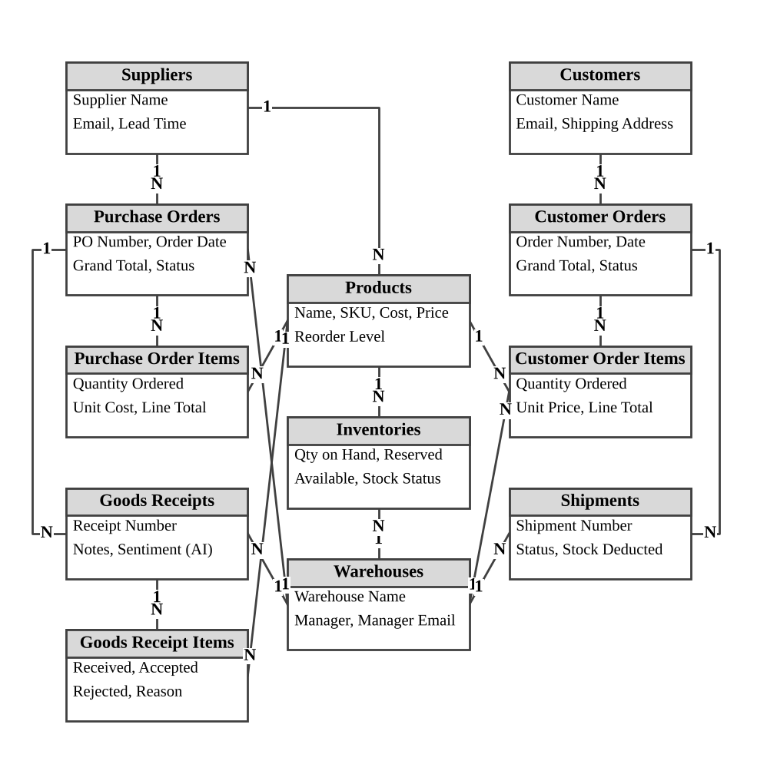
Figure 4.2: Entity–Relationship Diagram
Table 4.1: Entities and Relationships
Entity (Form) | Key Fields | Related To | Relationship Type | Implemented Using
Suppliers | Supplier Name, Email, Lead Time | Products; Purchase Orders | One-to-Many | Lookup in Products and Purchase Orders
Customers | Customer Name, Email, Shipping Address | Customer Orders | One-to-Many | Lookup in Customer Orders
Products | Product Name, SKU, Cost, Price, Safety Stock | Inventories; item forms | One-to-Many | Lookup in Inventories and in the three item forms
Warehouses | Warehouse Name, Manager, Manager Email | Inventories; Purchase Orders; Goods Receipts; Customer Order Items; Shipments | One-to-Many | Lookup in each related form
Purchase Orders | PO Number, Order Date, Status | Purchase Order Items; Goods Receipts | Parent–Child | Lookup in the child forms
Goods Receipts | Receipt Number, Notes, Sentiment | Goods Receipt Items | Parent–Child | Lookup in Goods Receipt Items
Customer Orders | Order Number, Order Date, Status | Customer Order Items; Shipments | Parent–Child | Lookup in the child forms
Inventories | Quantity on Hand, Reserved, Available | Products; Warehouses | Many-to-One | One record per product per warehouse

4.3 Form Design
One field-specification table is given for each of the twelve formsField types are named as in Zoho Creator, and link names are the names used in the Deluge scripts of Appendix C.
Table 4.2: Field Specification – Suppliers Form
Field Label | Link Name | Field Type | Mandatory | Validation / Default | Remarks
Supplier Name | supplier_name | Single Line | Yes |  | Display field for lookups
Company Registration or Tax Id | company_registration_or_tax_id | Single Line | No
Contact Person | contact_person | Name | No
Email Address | email_address | Email | Yes
Phone Number | phone_number | Phone | No | Country code +91
Address / Postal Code | address, postal_code | Address, Single Line | No
Supplier Category | supplier_category | Single Line | No
Payment Terms | payment_terms | Single Line | No
Typical Lead Time in Days | typical_lead_time_in_days | Number | No | Whole number ≥ 0 | Used for reorder planning

Table 4.3: Field Specification – Warehouses Form
Field Label | Link Name | Field Type | Mandatory | Validation / Default | Remarks
Warehouse Name | warehouse_name | Single Line | Yes |  | Display field for lookups
Warehouse Code | warehouse_code | Single Line | Yes | Unique
Address / Postal Code | address, postal_code | Address, Single Line | No
Warehouse Manager | warehouse_manager | Single Line | No |  | Name used in e-mails
Manager Email | manager_email | Email | Yes |  | Recipient of stock alerts
Contact Number | contact_number | Phone | No
Storage Capacity | storage_capacity | Number | No
Warehouse Status | warehouse_status | Radio | Yes | Active / Inactive / Other

Table 4.4: Field Specification – Goods Receipts Form
Field Label | Link Name | Field Type | Mandatory | Validation / Default | Remarks
Goods Receipt Number | goods_receipt_number | Single Line | Yes | Unique
Purchase Order | purchase_order | Lookup (Purchase Orders) | Yes | Drop down
Receipt Date | receipt_date | Date | Yes
Warehouse | warehouse | Lookup (Warehouses) | Yes | Drop down
Received By | received_by | Single Line | Yes
Receipt Status | receipt_status | Drop Down | Yes | Submitted …
Supplier Delivery Note Number | supplier_delivery_note_number | Single Line | No
Discrepancy Notes | discrepancy_notes | Multi Line | No |  | Source of the AI sentiment
Sentiment | sentiment | Zia AI field | No | Read-only | Positive / Neutral / Negative

4.4 Process and Workflow Design
Figure 4.3 shows the two automated processes and where Deluge scripts run. In the procure-to-stock process, a Purchase Order saved with the status Received triggers a form workflow whose Deluge script adds the quantity of every Purchase Order Item to Inventories and e-mails a summary. In the order-to-delivery process, a Shipment saved with the status Delivered triggers a form workflow whose Deluge script checks the Stock Deducted flag, deducts the ordered quantities, recalculates Stock Status and, when Available Quantity is below Safety Stock, e-mails the warehouse manager.
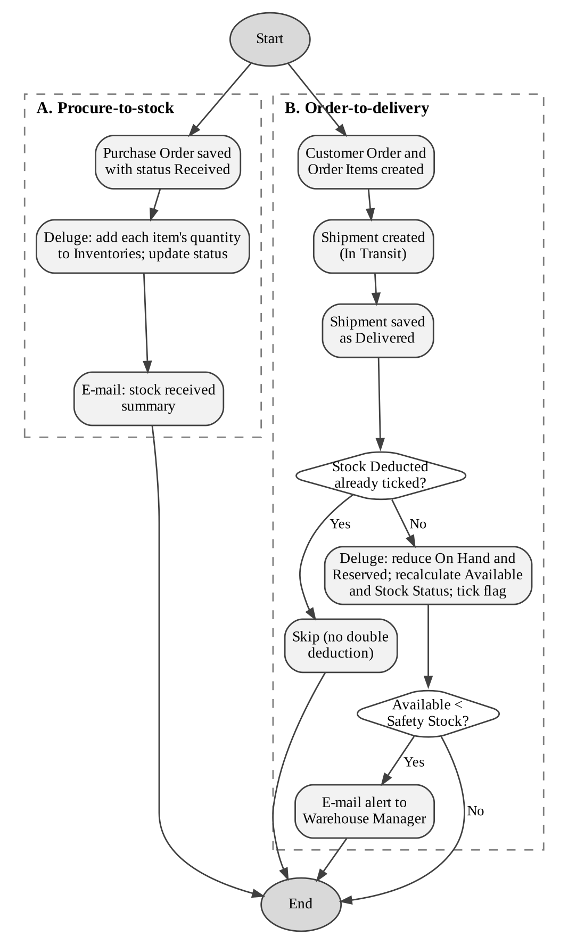
Figure 4.3: Workflow / Process Flow for Stock Update and Alerting

4.5 User Interface and Navigation Design
The application menu groups each form with its list report. Figure 4.4 shows the navigation structure: a Dashboard page at the top, followed by the master-data forms, the procurement forms, the sales and logistics forms and the stock form. The status lists that appear under some menu items (for example Stock Statuses and Shipment Statuses) are reports grouped by a status field.
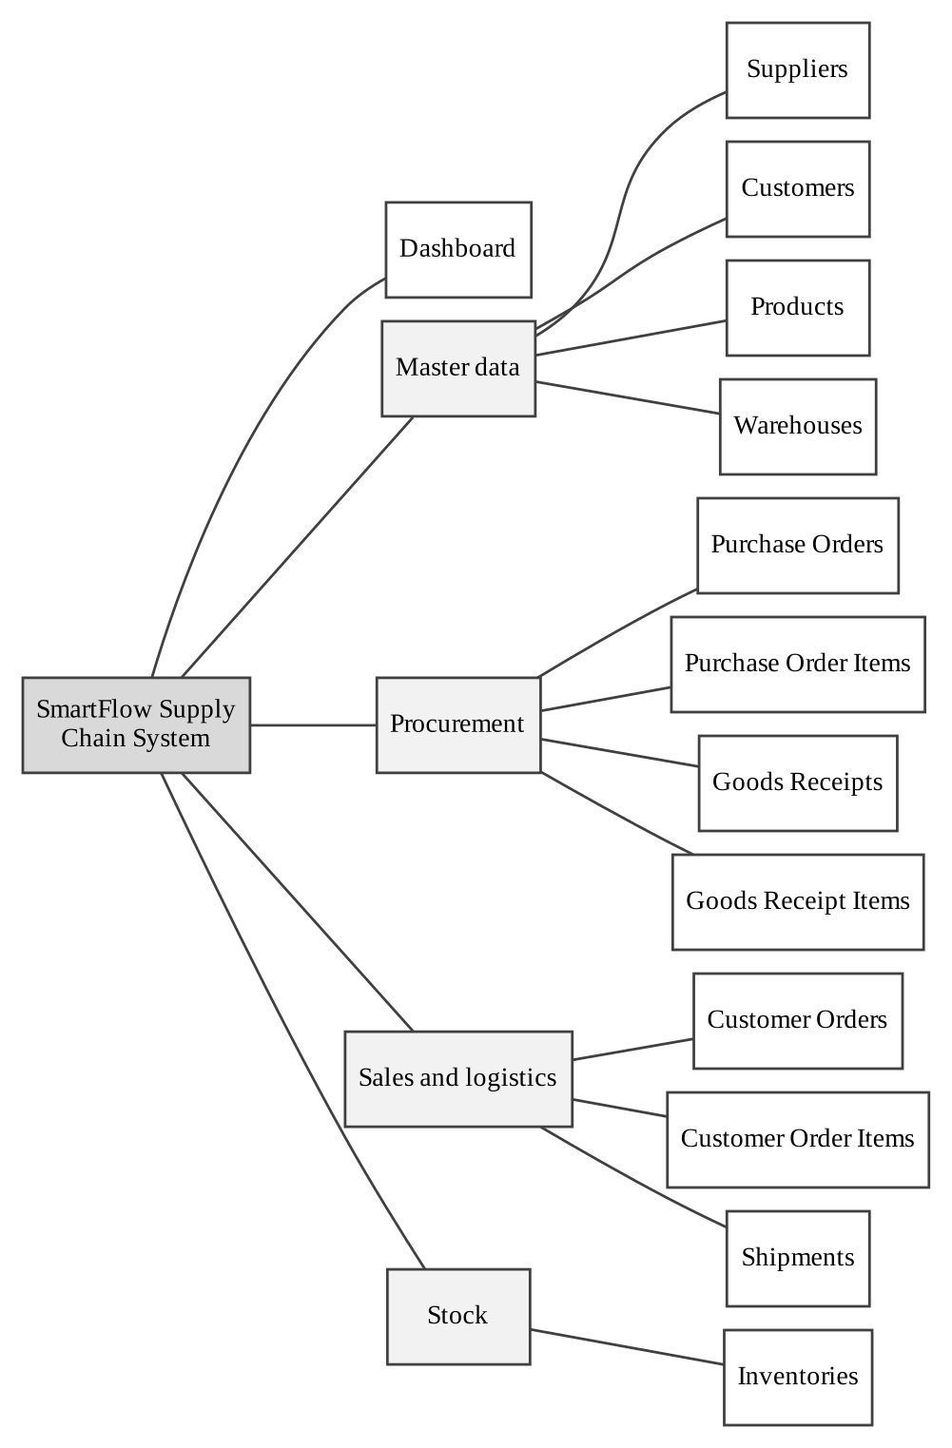
Figure 4.4: Navigation Structure of the Application

4.6 Access Control Design
Table 4.14 defines the permission matrix that Section 5.8 implements. A = Add, E = Edit, V = View, D = Delete, — = No access. The Sales Executive also acts as the logistics coordinator and therefore maintains shipments.
Table 4.14: Role–Permission Matrix
Component | Administrator | Procurement Manager | Warehouse Manager | Sales Executive
Form: Suppliers | A E V D | A E V | — | —
Form: Customers | A E V D | — | — | A E V
Form: Products | A E V D | A E V | V | V
Form: Warehouses | A E V D | — | A E V | —
Form: Inventories | A E V D | V | A E V | V
Form: Purchase Orders | A E V D | A E V | V | —
Form: Purchase Order Items | A E V D | A E V | V | —
Form: Goods Receipts | A E V D | V | A E V | —
Form: Goods Receipt Items | A E V D | V | A E V | —
Form: Customer Orders | A E V D | — | V | A E V
Form: Customer Order Items | A E V D | — | V | A E V
Form: Shipments | A E V D | — | V | A E V
Report: All Inventories | V | V | V | V
Page: Dashboard | V | V | V | V

CHAPTER 5

IMPLEMENTATION
This chapter describes how each part of the design was implemented on Zoho Creator. Screenshots are taken from the live application, and the complete Deluge source code is given in Appendix C.

5.1 Application Setup
The application was created in a Zoho Creator account hosted in the India data centre (creatorapp.zoho.in) on the free trial edition, with the name “SmartFlow Supply Chain System” and the link name smartflow-supply-chain-system1. The initial structure — forms, fields, lookups and menu — was generated from a text prompt using the Zia application builder, which saved the effort of creating twelve forms from scratch. The generated structure was then reviewed and corrected by hand: the display type of the Product lookup in the item forms was changed from Multi Select to Drop Down, helper fields (Stock Deducted, Qty Added To Stock) and a Manager Email field were added, and unused items were removed.
The menu is organised as one entry per form, each with its Add form and its list report, and a Dashboard page at the top (Figure 5.1). The default Zoho Creator theme was kept, because it already provides a readable dark navigation panel and a responsive layout.
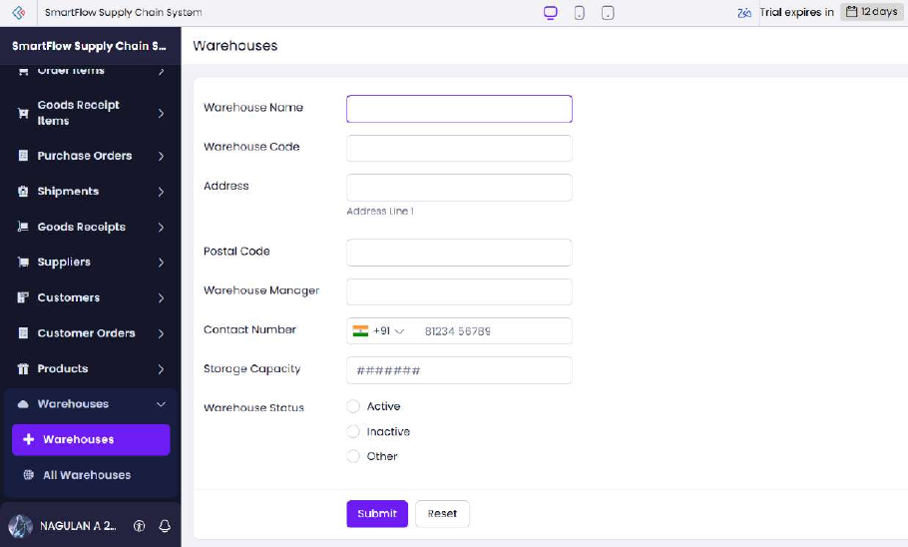
Figure 5.1: Application Navigation and the Warehouses Form in Live Mode

5.2 Forms and Data Capture
The twelve forms were specified in Section 4.3. Fourteen field types are used: Single Line, Multi Line, Number, Currency, Email, Phone, Address, Name, Date, Date-Time, Drop Down, Radio, Decision Box, URL, and Lookup. The principal design decisions were:
- Lookups for every relationship. Product, Warehouse, Supplier, Customer, Purchase Order, Goods Receipt and Customer Order are selected from existing records instead of being typed, so a name cannot be misspelled and scripts can rely on record IDs.
- Single-select lookups in item forms. The generated Product lookup defaulted to Multi Select, which makes one line item hold several products and breaks the stock calculation; it was changed to Drop Down.
- Validation and defaults. Key fields are mandatory, Warehouse Code and SKU must be unique, quantities must not be negative, and the calculated fields (Available Quantity, Line Total, Grand Total) are read-only.
- Helper fields for automation. Stock Deducted (a Decision Box in Shipments) and Qty Added To Stock (a Number in Purchase Order Items) are set only by scripts. They prevent the same delivery or receipt from changing stock twice.
The live forms are shown in Figure 5.2 to Figure 5.5.

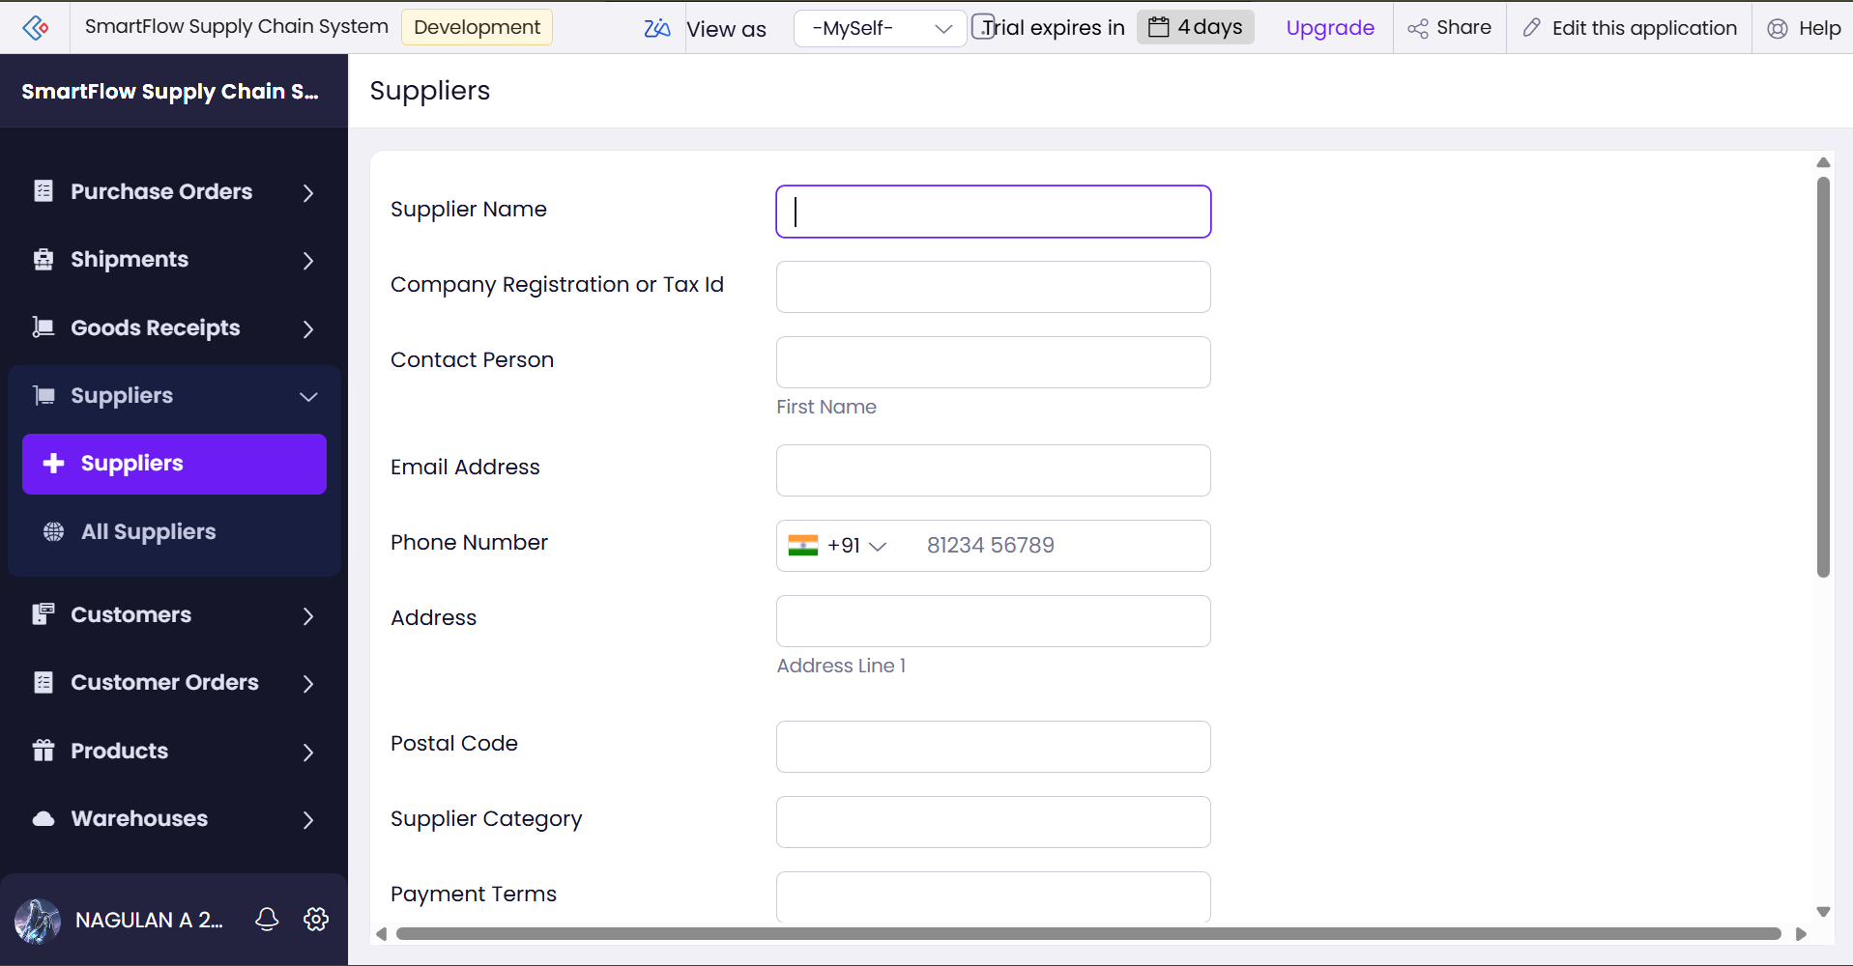
Figure 5.2: Suppliers Form (Live Mode)
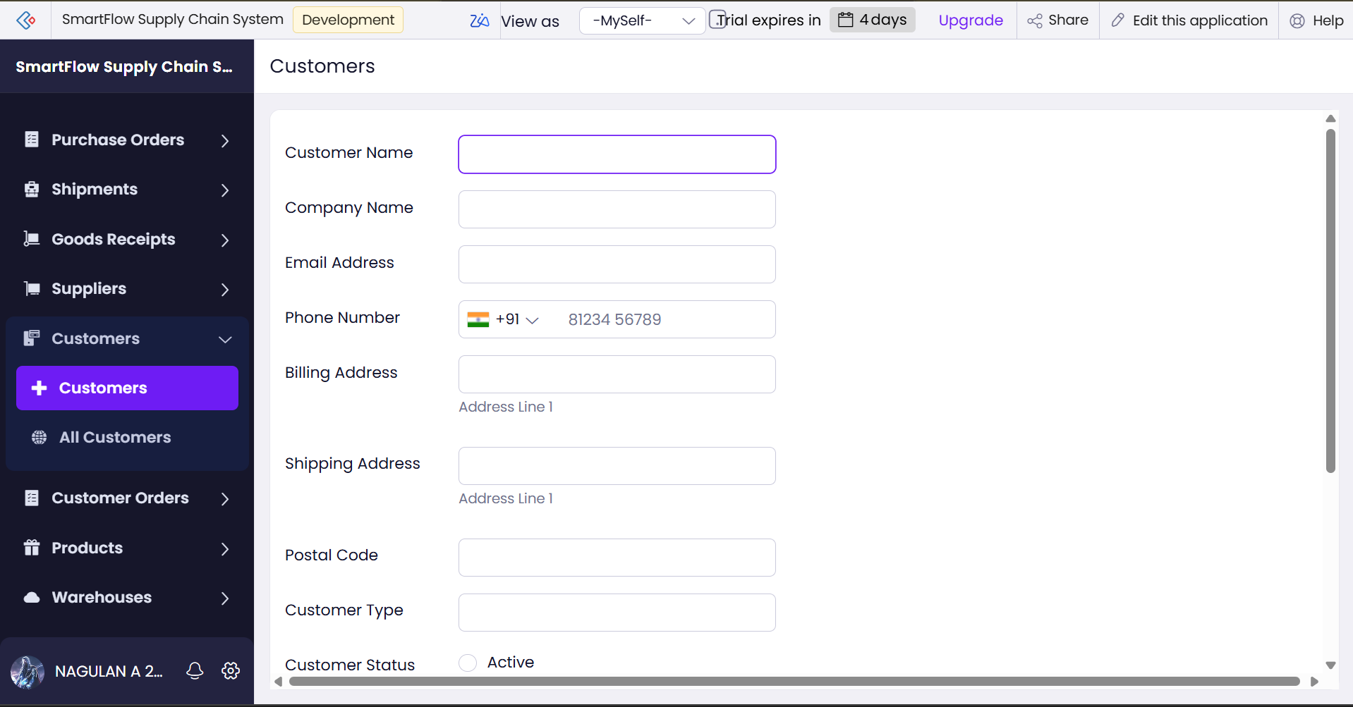
Figure 5.3: Customers Form (Live Mode)
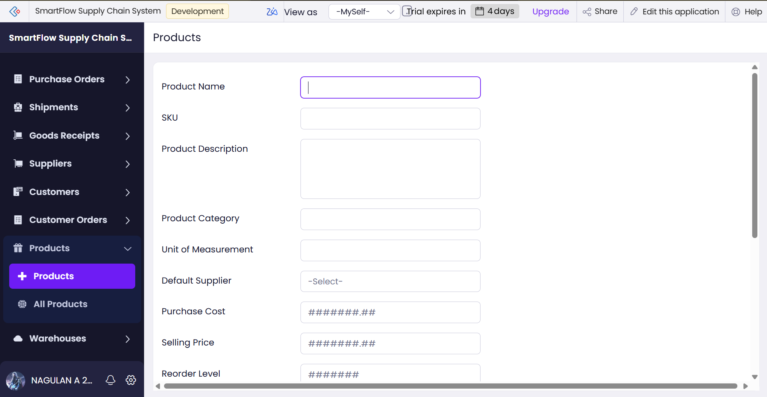
Figure 5.4: Products Form (Live Mode)
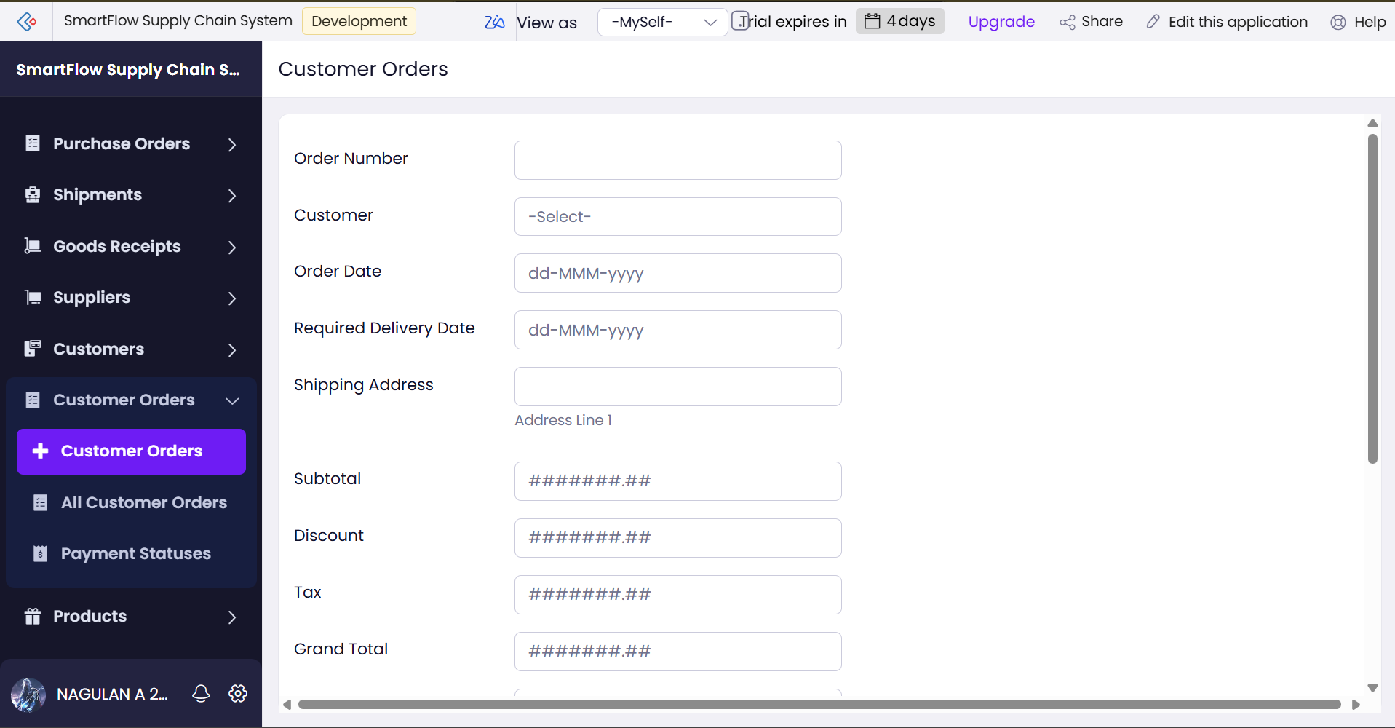
Figure 5.5: Customer Orders Form (Live Mode)

5.3 Reports
Every form has a list report that shows its records with sortable columns, quick search and the standard Add, Edit, View and Duplicate actions. Table 5.1 lists the reports. The stock position is read from the All Inventories report and a record can be opened in its detail view
Table 5.1: Reports Implemented
Report Name | Type | Based On | Used By
All Suppliers | List | Suppliers | Administrator, Procurement Manager
All Customers | List | Customers | Administrator, Sales Executive
All Products | List | Products | All roles
All Warehouses | List | Warehouses | Administrator, Warehouse Manager
All Inventories | List | Inventories | All roles
All Purchase Orders | List | Purchase Orders | Administrator, Procurement and Warehouse Managers
All Purchase Order Items | List | Purchase Order Items | Administrator, Procurement and Warehouse Managers
Goods Receipts Report | List | Goods Receipts | Administrator, Procurement and Warehouse Managers
All Goods Receipt Items | List | Goods Receipt Items | Administrator, Procurement and Warehouse Managers
All Customer Orders | List | Customer Orders | Administrator, Sales Executive
All Customer Order Items | List | Customer Order Items | Administrator, Sales Executive
All Shipments | List | Shipments | Administrator, Sales and Warehouse Managers
Status reports (Stock, Item, Purchase Order, Receipt, Payment and Shipment Statuses) | List grouped by a status field | Inventories, PO Items, Purchase Orders, Goods Receipts, Customer Orders, Shipments | Managers

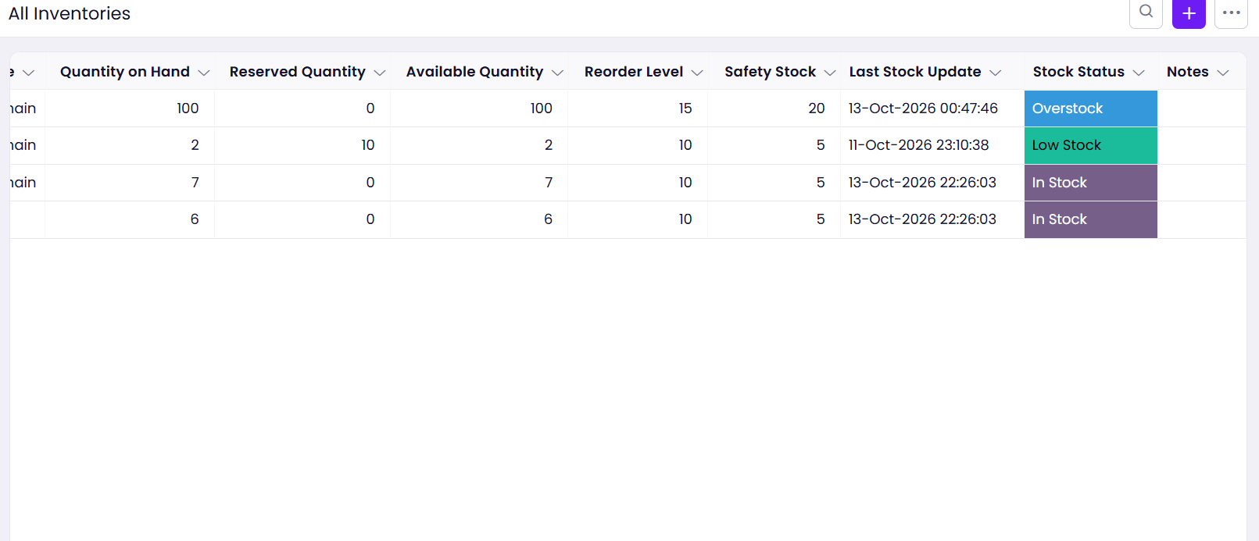
Figure 5.6: All Inventories Report Showing Quantity on Hand, Reserved, Available, Safety Stock and Stock Status

5.4 Pages and Dashboards
A Dashboard page is the first entry of the application menu. It is intended to give the administrator and managers a single view of the business: total units on hand and low-stock items from Inventories, purchase orders by status, customer orders by status and delayed shipments. The page is read-only for all roles, and the data comes from the same forms as the list reports so no data is duplicated.

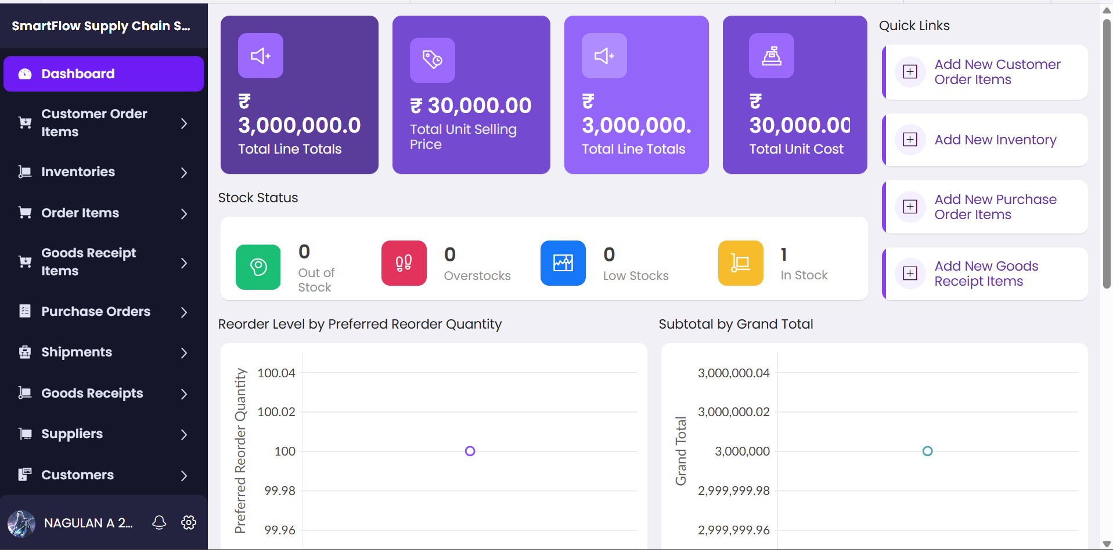Figure 5.7: Dashboard Page of the Application

5.5 Deluge Scripting
All business logic is written in Deluge [5]. Table 5.2 lists the ten scripts; the full source is in Appendix C. The scripts use Deluge data-access tasks (fetch records with criteria, update fields by assignment, insert records), control statements (if/else, for each), collections (lists and maps), built-in functions such as ifnull, and the sendmail task.
Table 5.2: Deluge Scripts Developed
Script ID | Location / Trigger | Purpose | Key Deluge Features
DS-01 | Inventories → Created or Edited → Successful form submission | E-mail the warehouse manager when Available Quantity is below Safety Stock | fetch, sendmail
DS-02 | Shipments → Successful form submission | When status is Delivered: deduct stock once, recalculate Stock Status, e-mail on low stock | fetch, for each, update, ifnull, sendmail
DS-03 | Purchase Orders → Successful form submission | When status is Received: add each item’s quantity to inventory once; e-mail summary | fetch, for each, insert, update, sendmail
DS-04 | Schedule: Daily Report (Inventories) | E-mail a daily inventory table, with low-stock rows highlighted | fetch, for each, HTML e-mail
DS-05 | Goods Receipt Items → Successful form submission | E-mail the receipt details to the warehouse manager | fetch, sendmail
DS-06 | Goods Receipts → Successful form submission | E-mail the procurement manager the AI sentiment of the discrepancy notes | fetch, sendmail
DS-07 | Inventories → Successful form submission | E-mail an Out of Stock alert when Available Quantity is zero | fetch, sendmail
DS-08 | Schedule: Out of Stock Daily Check (Inventories) | Daily check of all inventory; set status to Out of Stock and e-mail | fetch, for each, update, sendmail
DS-09 | Function getReceiptNotes | Returns the receipt number and notes of a goods receipt (AI agent tool) | function, fetch
DS-10 | Function saveReceiptSentiment | Saves a sentiment value on a goods receipt and e-mails on Negative (AI agent tool) | function, fetch, sendmail

Code 5.1 shows the core of DS-02. The Stock Deducted flag is checked first, so the stock changes only once for a shipment. The quantities are read with ifnull so an empty value is treated as zero, and the new stock figures are never allowed to fall below zero.
Code 5.1: Core of DS-02 – Deduct Stock on Delivery
if(statusText == "Delivered" && input.stock_deducted != true)
{
orderItems = customer_order_items[customer_order == input.customer_order];
for each item in orderItems
{
qty = ifnull(item.quantity_ordered, 0);
stockRecs = inventory[product == item.product && warehouse == item.warehouse];
for each inv in stockRecs
{
newOnHand = ifnull(inv.quantity_on_hand, 0) - qty;
if(newOnHand < 0) { newOnHand = 0; }
inv.quantity_on_hand = newOnHand;
...
}
}
input.stock_deducted = true; // never deduct twice
}

Code 5.2 shows the core of DS-03. The script re-fetches the saved Purchase Order record and reads its warehouse from the fetched record; it then adds only the difference between the ordered quantity and the quantity already added, which makes the update safe to run more than once.
Code 5.2: Core of DS-03 – Add Stock When a Purchase Order Is Received
po = purchase_orders[ID == input.ID];
if(po.purchase_order_status == "Received")
{
items = purchase_order_items[purchase_order == input.ID];
for each item in items
{
diff = ifnull(item.quantity_ordered, 0) - ifnull(item.qty_added_to_stock, 0);
if(diff != 0)
{
... // add diff to Quantity on Hand of the matching inventory
item.qty_added_to_stock = ifnull(item.quantity_ordered, 0);
}
}
}

Three practices were followed throughout. First, a script that updates a record does not trigger that form’s workflows, so the low-stock e-mail is written inside the delivery script instead of relying on the Inventories workflow to run. Second, helper flags make every script idempotent. Third, null checks with ifnull avoid errors on empty fields. The scripts were drafted with the help of an AI assistant and then corrected and tested by the author (Section 5.9 and Section 6.3).

5.6 Workflows and Automation
Table 5.3 lists the nine workflows. Seven are form workflows that run when a record is created or edited, and two are schedules that run daily. No approval process or Blueprint was needed for this scope.
Table 5.3: Workflows Implemented
Workflow | Type | Form | Trigger / Schedule | Action
Notify Low Stock Alert | Form | Inventories | Created or Edited → Successful form submission | DS-01
Stock set up | Form | Shipments | Created or Edited → Successful form submission | DS-02
Add Stock on PO Received | Form | Purchase Orders | Created or Edited → Successful form submission | DS-03
Goods Receipt Notification | Form | Goods Receipt Items | Created or Edited → Successful form submission | DS-05
Sentiment E-mail | Form | Goods Receipts | Created or Edited → Successful form submission | DS-06
Out of Stock Alert | Form | Inventories | Created or Edited → Successful form submission | DS-07
Customer to CRM | Form | Customers | Created → Successful form submission | Zoho CRM integration action
Daily Report | Schedule | Inventories | Daily at the configured time | DS-04 / Send Mail with report attached
Out of Stock Daily Check | Schedule | Inventories | Daily at the configured time | DS-08

5.7 Integrations
Table 5.4 summarises the integrations. The main one is Zoho CRM: when a customer is created, a workflow action creates a contact in the CRM Contacts module, so the sales team does not type the same customer twice [10]. The action uses an OAuth connection to Zoho CRM, so no password or key is stored in the script. shows the connectors offered by the Integrations tab of a workflow action, shows the field mapping, and Figure 5.11 shows the CRM Contacts module that receives the records.
Table 5.4: Integrations Implemented
Integration | Mechanism | Purpose | Authentication
Zoho CRM | Workflow integration action with a Zoho OAuth connection | Create a CRM contact for every new customer | OAuth connection (no credentials in script)
E-mail service | Deluge sendmail task and the Send Mail action | Alerts, receipts and reports | Sent from the application administrator’s account
Zia AI services | Built-in AI field and custom OCR model | Sentiment analysis and invoice OCR | Inside the Zoho Creator account

No call to an external REST service with invokeurl and no webhook was implemented in this version. A weather or route-distance service for delay prediction is listed as a future enhancement in Section 9.2.

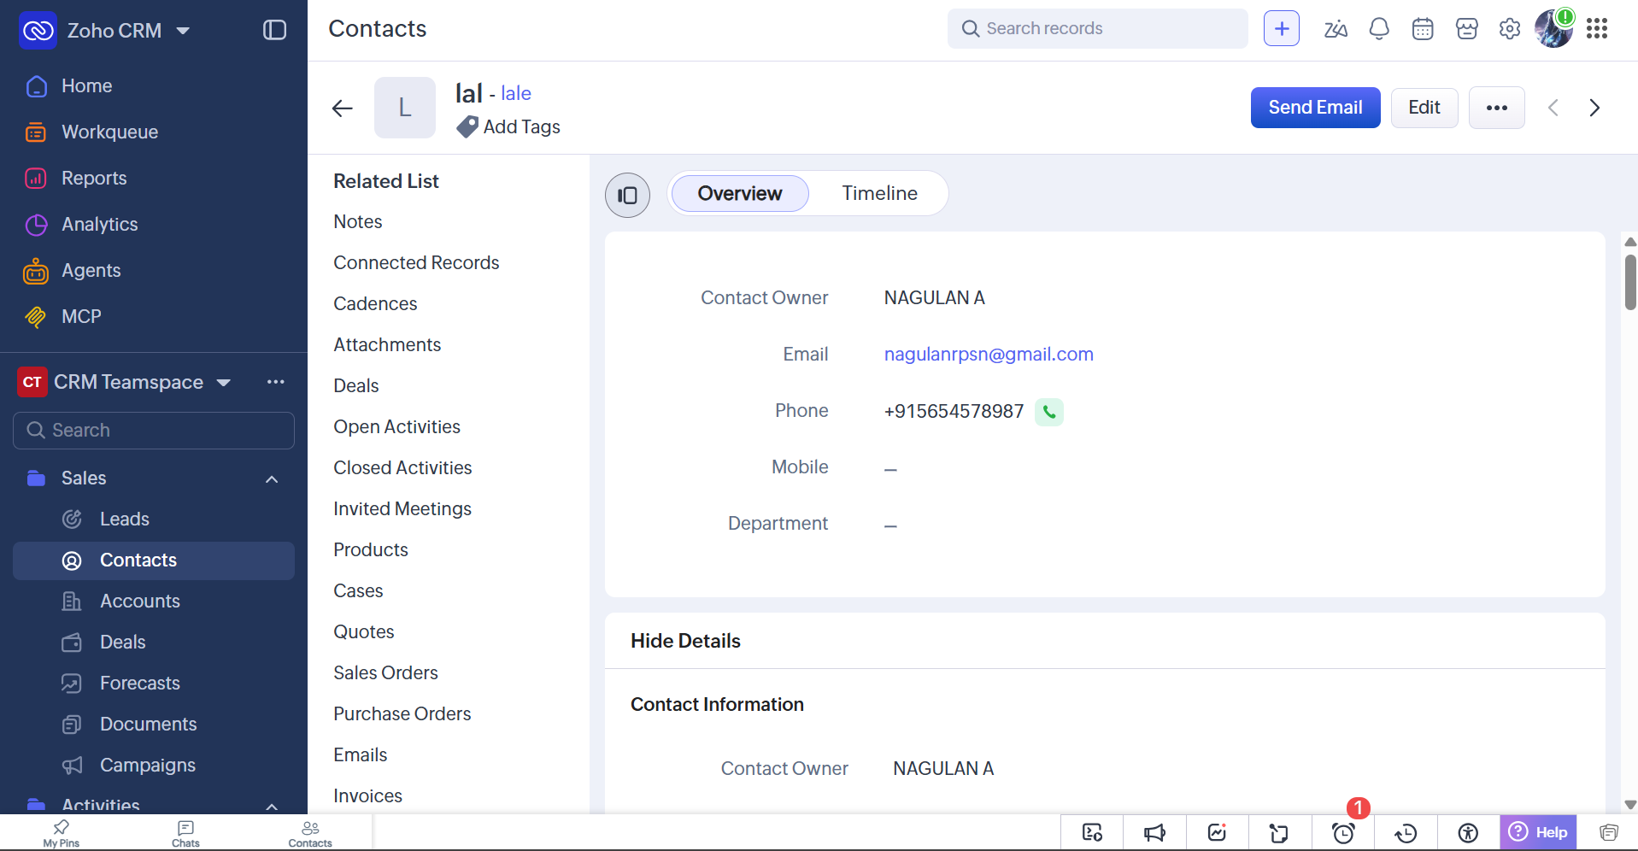

Figure 5.8: Zoho CRM Contacts Module

5.8 User Management and Role-Based Access
Four internal roles are defined — Administrator, Procurement Manager, Warehouse Manager and Sales Executive — and a permission profile is created for each according to the matrix in Table 4.14.

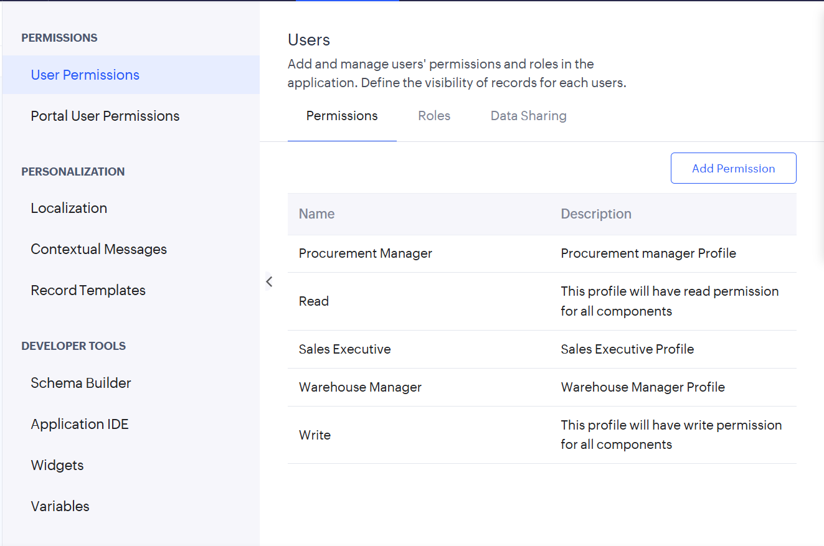 Figure 5.9: Role Profiles and Restricted User View

5.9 AI and Analytics Features
Table 5.5 lists the Zia AI features used. An AI sentiment field on the Goods Receipts form classifies Discrepancy Notes as Positive, Neutral or Negative, and workflow DS-06 e-mails the procurement manager with the result. A custom OCR model reads the Invoice Number, Date and Total from supplier invoices. It was retrained on five invoices in one layout after the first model returned empty values (Section 6.4). An AI agent, Goods Receipt Analyzer, was also built as a prototype. Table 5.5: AI and Analytics Features
Feature | Form | Model / Tool | Purpose | Status
Sentiment analysis | Goods Receipts | Zia AI field (ready-made) | Classify discrepancy notes; alert the procurement manager | Implemented
OCR | Goods Receipts | Custom OCR model (5 PDF samples) | Read invoice number, date and total from supplier invoices | Model created; accuracy tested
AI agent | Goods Receipts | Agent with two Deluge function tools | Classify notes and save the result | Prototype
Reports and dashboard | Inventories, Orders, Shipments | List reports and Dashboard page | Stock, order and delivery overview | Implemented

Use of AI assistance. The initial application structure was generated by the Zia application builder from a prompt, and the Deluge scripts were drafted with an AI assistant. Every script was read line by line, run against test data, debugged where it failed, and corrected. The defects found in AI-drafted code — a reference to a form that did not exist, a wrong field type assumption, and a wrong source of a field value — are listed in Table 6.2. Where an AI feature produced a doubtful result, as in the first OCR model, the result was checked and the feature was reworked.

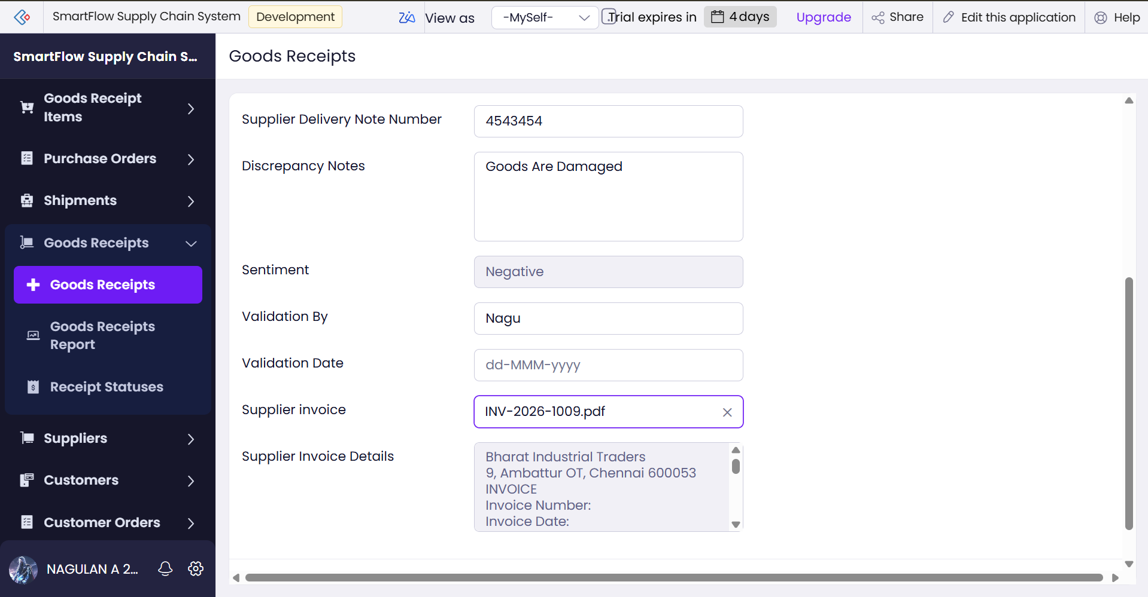 Figure 5.10: Goods Receipt Record with the AI Sentiment Result

5.10 Pro-Code Extension
No widget, Catalyst function or client script was developed. All logic fits within form workflows, schedules and Deluge custom functions, which are native to Zoho Creator. The two custom functions (DS-09 and DS-10) were created to serve as tools for the AI agent and show how reusable logic can be written once and called from other places. A pro-code extension would be justified only for needs that the platform does not meet, such as a custom chart widget or heavy computation; none arose in this project.

5.11 Mobile and Portal Access
The application is automatically available in the Zoho Creator mobile app for Android and iOS, where a warehouse manager can record a goods receipt on the receiving dock or a sales executive can mark a shipment as Delivered. No separate mobile development was required. A customer or supplier portal was not built because it adds user management and security work beyond the scope of an internal system for four users; it is listed as a future enhancement.
CHAPTER 6

TESTING AND DEBUGGING

6.1 Testing Strategy
Testing was done in three layers. Script-level testing used the info statement and the workflow execution log to print values such as the number of order items found and the reason for a skipped update. Functional testing used small sets of test records to run each workflow end to end and to check the stock figures and the e-mails received. Negative testing entered invalid data and tried restricted forms with a restricted user. Tests were first run in the Development environment and repeated in the Stage environment before deployment.

6.2 Test Cases
Table 6.1: Test Cases and Results
TC ID | Feature / FR | Test Input | Expected Result | Actual Result | Status
TC-01 | FR-01 Master data | Add a supplier, customer, product and warehouse with all mandatory fields | Records saved and visible in the list reports | Record Saved | Pass
TC-02 | FR-01 Validation | Save a customer without an e-mail address | Form shows a mandatory-field error | Error Shown | Pass
TC-03 | FR-02 Stock | Add an inventory record: On Hand 100, Reserved 0 | Available Quantity = 100; status In Stock | 100 | Pass
TC-04 | FR-11 Low stock | Save inventory with Available Quantity below Safety Stock | Low Stock status; e-mail to the warehouse manager | Yes | Pass
TC-05 | FR-04 PO received | Set a purchase order with one item (50 units) to Received | Stock increases by 50; summary e-mail sent | Yes | Pass
TC-10 | FR-11 Out of stock | Deliver an order that leaves zero stock | Status Out of Stock; Out of Stock e-mail | Email sent | Pass
TC-13 | FR-06 Sentiment | Save a goods receipt with the note “Goods arrived damaged and very late” | Sentiment field = Negative | Sentiment classified as expected | Pass
TC-14 | FR-07 OCR | Upload a sample supplier invoice | Invoice number, date and total extracted | First model returned empty values; retrained with a new layout | Pass
TC-17 | FR-15 Access | Sales Executive opens Purchase Orders | Access denied; form not in menu | Access denied | Pass

6.3 Debugging Deluge Scripts
Errors were found in three ways: the red error banner in the script editor, the info log of a workflow run, and test e-mails. Figure 6.1 shows the editor refusing a script that inserts into a form (alert_logs) that does not exist in the application; the optional block was removed. Figure 6.2 shows the error “Invalid collection object found”, which appeared because Shipment Status is a drop-down and not a lookup, so reading a sub-field from it is invalid.
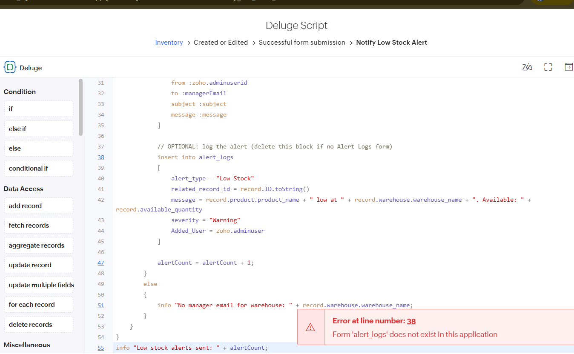
Figure 6.1: Script Editor Error: Form alert_logs Does Not Exist
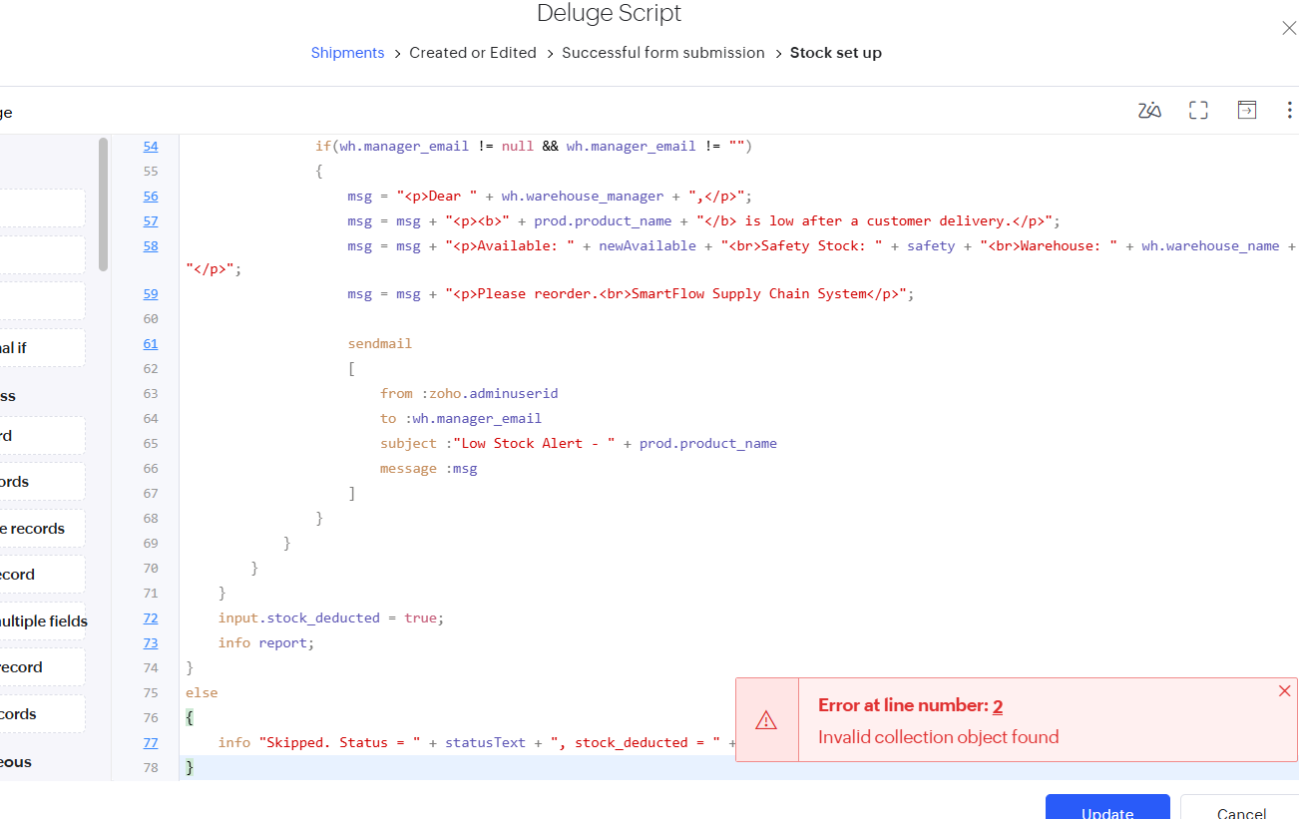
Figure 6.2: Script Editor Error: Invalid Collection Object Found

6.4 Defect Log
Table 6.2: Defect Log
Bug ID | Description | Root Cause | Fix Applied | Status
BUG-01 | Script rejected: “Form alert_logs does not exist” | Script inserted into a form that was never created | Removed the optional log block | Closed
BUG-02 | Stock not deducted and no e-mail on delivery | Stock Deducted flag was already ticked from an earlier test, so the guard skipped the script | Re-tested with a new shipment; reset the flag during testing | Closed
BUG-03 | “Invalid collection object found” on the status line | Shipment Status is a drop-down, but the script read a sub-field as for a lookup | Compared the field value directly | Closed
BUG-04 | “Variable delivery_warehouse is not defined” | Value was read from input instead of the fetched Purchase Order record | Fetched the record and read the field from it | Closed
BUG-05 | Purchase order update reported “Items added to stock: 0” | Qty Added To Stock already equalled the ordered quantity, so the difference was zero | Reset the helper field to 0 and re-tested; field set to read-only | Closed
BUG-06 | Stock matching failed for line items | Product lookup in an item form was Multi Select | Changed the display type to Drop Down | Closed
BUG-07 | Sentiment showed Positive for every record | A duplicate custom sentiment field and script conflicted with the Zia AI field | Removed the custom field and script; kept the AI field | Closed
BUG-08 | OCR test returned -NA- for all fields | Incomplete annotation and a complex layout in the first model | New model trained on five simplified invoices with matching labels | Closed

6.5 User Acceptance Testing
Table 6.3 records the acceptance testing by two intended users. The feedback is to be recorded after the sessions.
Table 6.3: User Acceptance Testing Feedback
Tester | Role | Task Performed | Result | Feedback | Action Taken
Naveen ST | Warehouse Manager | Receive goods and check stock after delivery | Received | Good | No
Naveen | Sales Executive | Create an order and mark the shipment Delivered | Done | Good | No

CHAPTER 7

DEPLOYMENT, SECURITY AND GOVERNANCE

7.1 Environments and Deployment Strategy
Zoho Creator separates an application into three environments. All building and script changes are made in Development. The tested version is deployed to Stage, where the test cases of Chapter 6 are repeated with test data. When Stage passes, the application is deployed to Production, where the four real users work. Production is not edited directly; every change goes through Development and Stage again. Deployment copies the structure of the application (forms, reports, workflows, scripts) but not the records, so master data such as warehouses, suppliers, products and customers is entered afresh in Production. Connections to other services are created again in Production, and the time zone is set to India Standard Time because schedules run in that zone.

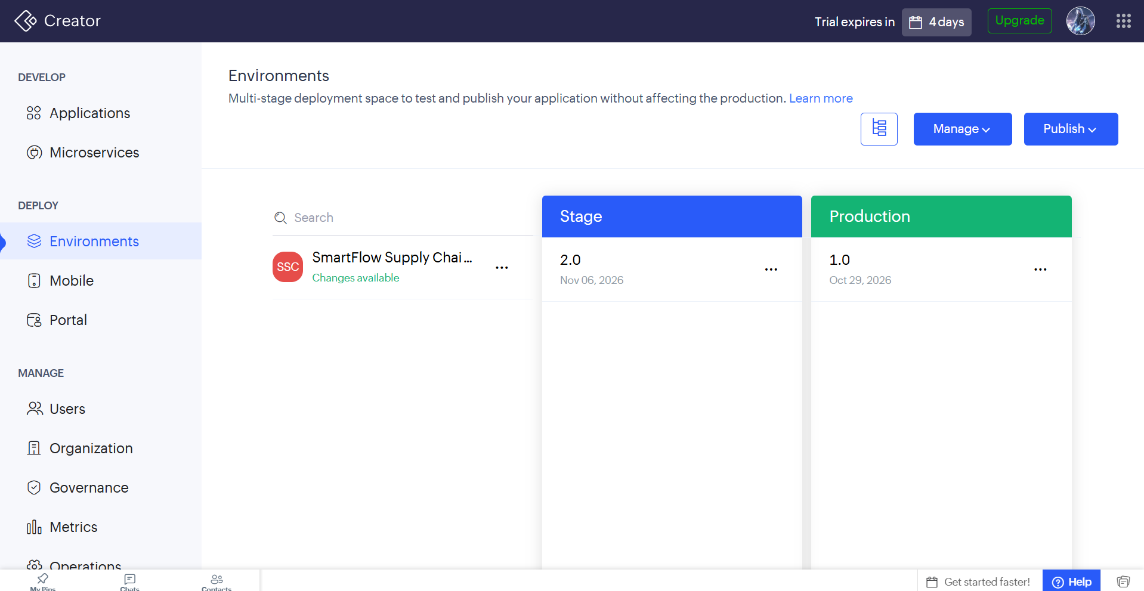 Figure 7.1: Deployment Across Environments
Table 7.1: Deployment Checklist
Checklist Item | Why It Matters | Done
Debug and test e-mail addresses replaced by real role addresses | Alerts must reach the right people | Done
Time zone set to IST and schedules enabled | Schedules run at the intended local time | Done
Test cases repeated in Stage | Confirms behaviour before Production | Done
Four users invited with the correct role and profile | Role-based access | Done
Zoho CRM connection re-authorised in Production | Connections are not copied between environments | Done
Warehouse, supplier, product and customer master data entered; Manager Email filled | Production starts without records | Done
Helper fields start at 0 / unticked on new records | Prevents skipped stock updates | Done
AI models published and the AI field working | AI features depend on the published model | Done
Application exported as a backup file | Recovery | Done

7.2 Performance Optimisation
The optimisations below were applied while writing the scripts. They were not timed, because the data volume of the trial is small; the benefits are therefore described qualitatively.
Table 7.2: Performance Optimisations Applied
Issue | Optimisation Applied | Where Applied | Benefit
Scripts re-ran on every save | Guard flags (Stock Deducted, Qty Added To Stock) skip work already done | DS-02, DS-03 | Each delivery or receipt changes stock once; unnecessary updates avoided
Fetching more records than needed | Criteria on product and warehouse when fetching inventory; criteria on the order for items | DS-02, DS-03 | Only the matching records are read
Mail sent repeatedly while stock stays low | Low-stock mail is sent on the stock event, and the out-of-stock check runs once a day | DS-01, DS-02, DS-08 | Fewer duplicate e-mails
Heavy reporting on demand | Inventory report generated once a day by a schedule | DS-04 | No manual report preparation

7.3 Security Features
Table 7.3: Security Controls
Control | Implementation | Risk Addressed
Role-based permissions | Four profiles with form-, report- and page-level permissions (Table 4.14) | Unauthorised viewing or editing of data
OAuth connection | Zoho CRM accessed through an authorised connection; no credentials in scripts | Credential leakage
Read-only system fields | Stock Deducted, Qty Added To Stock, calculated and AI fields are read-only for users | Accidental or deliberate tampering with automation flags
Mandatory fields and validations | Mandatory, unique and range rules on key fields | Invalid or duplicate data
Hosted security | HTTPS access and Zoho account authentication provided by the platform | Eavesdropping and unauthorised login
Audit trail | Record history of who added or modified a record | Lack of accountability

7.4 Governance and Administration
- Audit trail: Zoho Creator records the user and time of each record change, which supports accountability.
- Naming conventions: forms, fields and link names follow the Zoho naming pattern (for example quantity_on_hand), and scripts are named by their script ID.
- Change control: changes are made only in Development and promoted to Stage and Production.
- Backup: the application can be exported as a file before major changes and at the end of the trial.
- User administration: the administrator invites users, assigns the role and profile, and removes access when a user leaves.
- Monitoring: workflow execution logs and test e-mails are used to confirm that automations run.

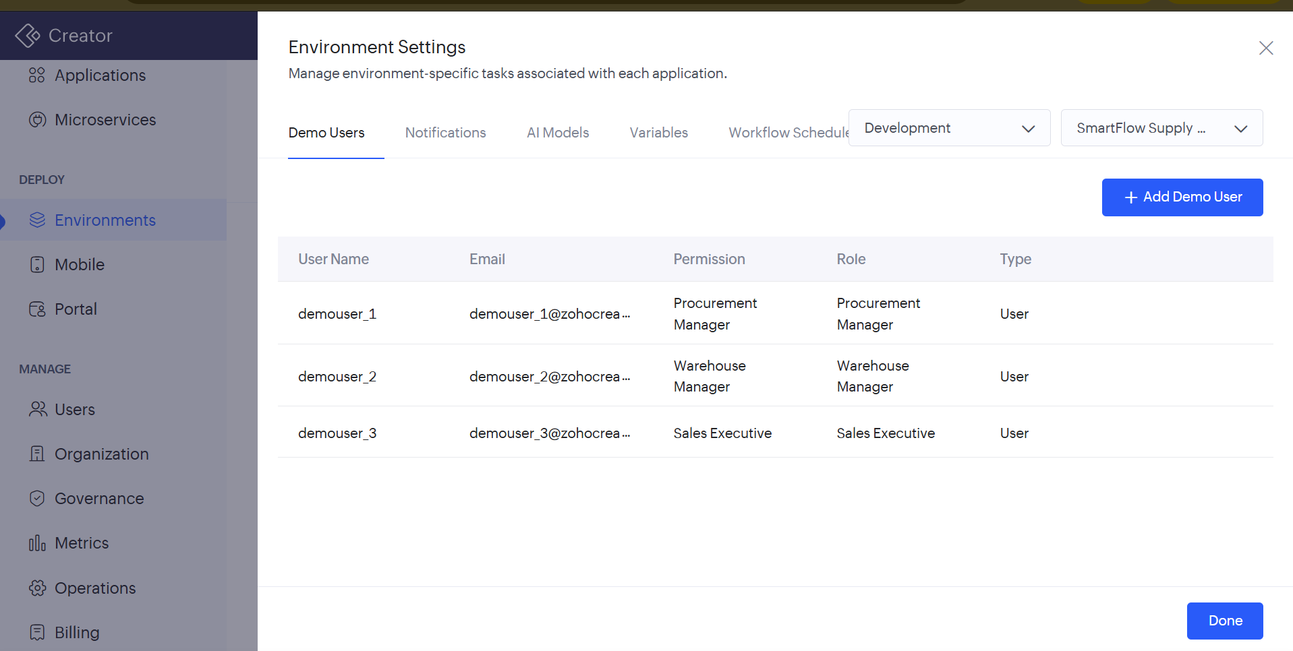 Figure 7.2: Administration and Audit Trail
CHAPTER 8

RESULTS AND DISCUSSION

8.1 Application Output
The following scenario shows the application at work. A product has 100 units on hand and a Safety Stock of 20 in the warehouse Chennai_main, and the warehouse manager’s e-mail is configured. A customer order for 90 units is created and a shipment is raised. When the shipment is saved with the status Delivered, the workflow reduces Quantity on Hand and Reserved Quantity, recalculates Available Quantity and sets the Stock Status, ticks the Stock Deducted flag, and — because the new Available Quantity (10) is below the Safety Stock (20) — e-mails the warehouse manager. The updated stock is visible in the Inventories report (Figure 8.2), and the Stock Deducted flag prevents a second deduction when the shipment is saved again. During testing the stock was reduced and the low-stock e-mail was received and Current Inventory received daily through Email.

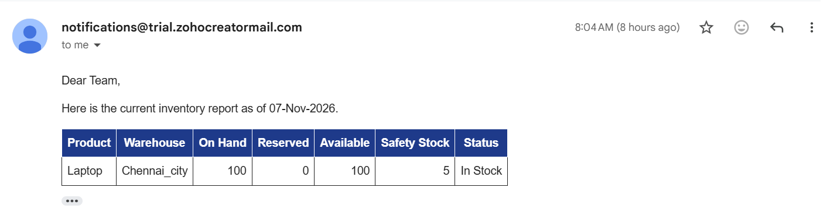
Figure 8.1: Daily Inventory

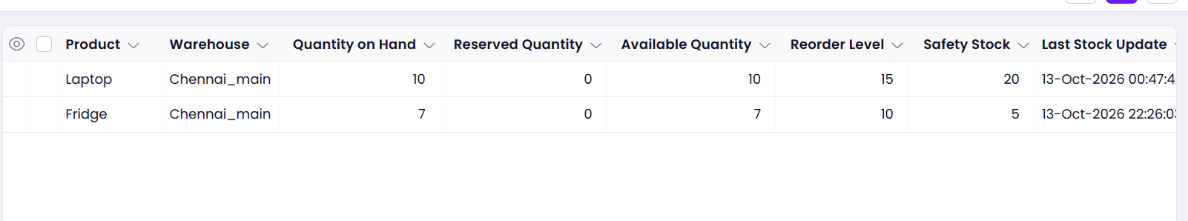
Figure 8.2: Inventories Report Showing Product-Wise Stock in Chennai_main

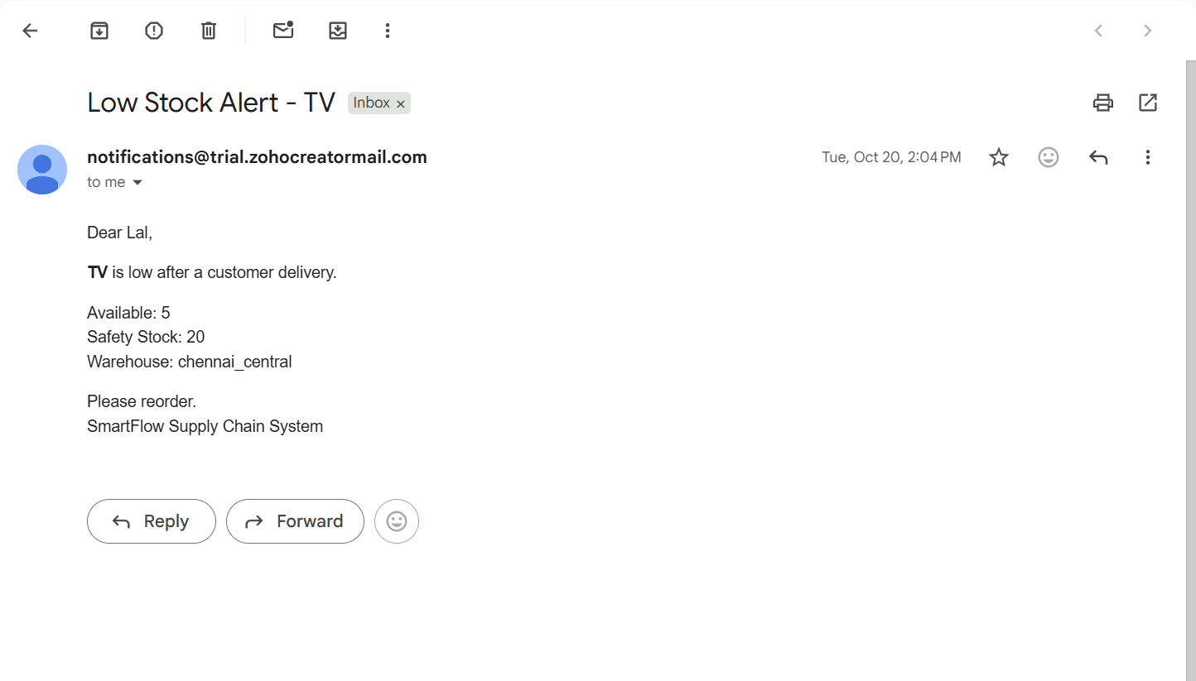 Figure 8.3: Low Stock Alert E-mail

8.2 Achievement of Objectives
Table 8.1: Achievement of Objectives
Objective | Outcome | Evidence
1. Data model and twelve linked forms | Twelve forms with lookups and validations | Section 4.2–4.3, 5.2
2. Automated stock updates, alerts, notifications and reporting | Scripts DS-01 to DS-08 and nine workflows | Section 5.5, 5.6, 8.1
3. Reports and dashboard | Twelve list reports, status reports and a Dashboard page | Section 5.3, 5.4
4. Zoho CRM integration and Zia AI | CRM contact creation; sentiment field; OCR model | Section 5.7, 5.9
5. Role-based access for four roles | Four profiles per Table 4.14 | Section 4.6, 5.8
6. Deployment for four users | Development, Stage and Production with checklist | Section 7.1

8.3 Comparison with the Existing System
Table 8.2: Existing System versus SmartFlow
Measure | Existing System | SmartFlow
Stock update after goods receipt | Manual entry in a spreadsheet | Automatic when the purchase order is marked Received
Stock update after delivery | Manual entry | Automatic when the shipment is marked Delivered
Low-stock detection | Noticed when an order cannot be fulfilled | E-mail alert at the moment stock falls below the safety level
Customer data entry | Typed in two places | Entered once; contact created in Zoho CRM
Goods-receipt problems | Paper notes | Recorded, classified by Zia, and e-mailed
Reports | Prepared by hand | List reports, dashboard and a daily e-mail report
Access control | None | Four role profiles

8.4 Limitations of the Low-Code Approach
- Script updates do not trigger workflows. A record updated by a script does not fire that form’s workflows, so the low-stock e-mail had to be written inside the delivery script.
- Criteria cannot compare two fields. A fetch criterion compares a field to a value, not to another field, so the Available-versus-Safety-Stock comparison is done inside the script.
- Dependence on link names. Scripts break when a field’s link name differs from the one assumed, which caused several of the defects in Table 6.2.
- AI models need suitable data. The OCR model required at least five PDFs of one layout and careful annotation, and the first model failed.
- Trial limits and vendor lock-in. The trial period, environment availability and the platform-specific Deluge language limit portability.

8.5 Reflection on the No-Code → Low-Code → Pro-Code Spectrum
The project used all three levels in proportion. No-code features produced most of the application: the Zia-generated forms, list reports, field permissions, the CRM integration action and the AI sentiment field. Low-code was needed for the business rules that no configuration screen provides: stock arithmetic, idempotency flags, HTML e-mails and scheduled checks, all written in Deluge. Pro-code extension (widgets or external services) was not needed, but the Deluge functions show the first step towards reusable code. A sensible rule that emerged is to use configuration wherever possible, write a script only for logic that must be repeated reliably, and move to pro-code only when the platform cannot meet a requirement.
CHAPTER 9

CONCLUSION AND FUTURE ENHANCEMENTS

9.1 Conclusion
SmartFlow Supply Chain System shows that a complete, role-secured business application can be built on a low-code platform with a small amount of scripting. Twelve linked forms record suppliers, customers, products, warehouses, stock, purchasing, goods receipts, sales and shipments once; Deluge workflows keep stock correct after each receipt and delivery; alerts reach the warehouse manager when stock is low or exhausted; Zia AI classifies goods-receipt notes; Zoho CRM receives new customers; and four user roles see only what they need. Testing and debugging produced eight documented defects, which were analysed and fixed, and the application is deployed through the Development, Stage and Production environments.
The main lessons were that automation must be idempotent, that platform behaviours such as script updates not triggering workflows must be understood early, and that AI features need good sample data and checking.

9.2 Future Enhancements
- Reserve stock automatically when a customer order is Confirmed, so Reserved and Available Quantity reflect promises to customers.
- Add an approval process for high-value purchase orders, routed by amount.
- Integrate with Zoho Books to raise a sales invoice when a shipment is Delivered.
- Call an external weather or route service with invokeurl to flag delivery delay risk, and train a Zia prediction model on shipment history.
- Add Kanban and map reports for orders and shipments, and a customer portal for order tracking.

9.3 Learning Outcomes and Career Relevance
The project gave practical experience of data modelling, form and report design, Deluge scripting, workflow automation, integration through connections, role-based security, AI features and environment-based deployment on Zoho Creator. The experience of reading error messages, using logs and fixing defects is directly relevant to roles such as low-code developer, business-application analyst and automation engineer, where delivering working solutions quickly and safely is the main skill.

REFERENCES
[1] S. Chopra and P. Meindl, Supply Chain Management: Strategy, Planning, and Operation, 7th ed. Harlow, U.K.: Pearson, 2019.
[2] A. C. Bock and U. Frank, “Low-code platform,” Business & Information Systems Engineering, vol. 63, no. 6, pp. 733–740, 2021.
[3] Gartner, Inc., “Magic Quadrant for Enterprise Low-Code Application Platforms,” Gartner Research, 2023.
[4] Zoho Corporation, “Zoho Creator Help Documentation.” [Online]. Available: https://www.zoho.com/creator/help/ (Accessed: 07 November 2026).
[5] Zoho Corporation, “Deluge Script Reference Guide.” [Online]. Available: https://www.zoho.com/deluge/ (Accessed: 07 November 2026).
[6] W. Rosam and O. Kalnichevski, Low-Code Development: A Practical Guide. New Delhi, India: BPB Publications.
[7] A. Sahay, A. Indamutsa, D. Di Ruscio, and A. Pierantonio, “Supporting the understanding and comparison of low-code development platforms,” in Proc. 46th Euromicro Conf. Software Engineering and Advanced Applications (SEAA), 2020, pp. 171–178.
[8] R. Waszkowski, “Low-code platform for automating business processes in manufacturing,” IFAC-PapersOnLine, vol. 52, no. 10, pp. 376–381, 2019.
[9] K. Rokis and M. Kirikova, “Challenges of low-code/no-code software development: A literature review,” in Perspectives in Business Informatics Research (BIR 2022), Lecture Notes in Business Information Processing, vol. 462. Cham, Switzerland: Springer, 2022, pp. 3–17.
[10] Zoho Corporation, “Zoho CRM Help.” [Online]. Available: https://www.zoho.com/crm/help/ (Accessed: 07 November 2026).

APPENDIX A – ZOHO CREATOR FEATURE COVERAGE CHECKLIST
Table A.1 lists each Zoho Creator feature, whether it is implemented, where it is in the application and which section and figure evidence it. Cells marked in yellow are to be confirmed against the live application before submission.
Table A.1: Feature Coverage Checklist
Unit | Zoho Creator Feature | Done | Where in the Application | Report Section | Figure / Code No.
I | Application created & sections/menu organised | Y | Application menu | 5.1 | Figure 5.1
II | Forms with ≥ 8 distinct field types | Y | 12 forms | 5.2 | Figure 5.2
II | Lookup field (relationship between forms) | Y | All item and parent forms | 4.2, 5.2 | Figure 4.2
II | Subform (parent–child data) | N | Not used; item forms used | 4.2, 5.2 | —
II | Field validations / layout rules | Y | Mandatory, unique, range rules | 5.2 | Figure 5.6
II | List report with filter, grouping, custom action | Y | List reports; status reports | 5.3 | Figure 5.14
II | Kanban / Calendar / Timeline / Map report | N | — | 5.3 | —
II | Pivot table / chart report | N | Dashboard charts (to confirm) | 5.3 | —
II | Page / dashboard built with UI Builder | Y | Dashboard page | 5.4 | Figure 5.16
II | Deluge – form events (validate / success / field actions) | Y | Successful form submission scripts | 5.5 | Code 5.1
II | Deluge – functions, fetch, loops, collections | Y | DS-02, DS-03, DS-09 | 5.5 | Code 5.2
II | E-mail / in-app notifications | Y | DS-01 to DS-08 | 5.5, 5.6 | Figure 8.2
II | Form workflow | Y | Seven form workflows | 5.6 | Table 5.3
II | Scheduled workflow | Y | Daily Report; Out of Stock Daily Check | 5.6 | Figure 5.18
II | Approval process | N | — | 5.6 | —
II | Blueprint | N | — | 5.6 | —
II | Batch / report workflow | N | — | 5.6 | —
II | Testing & debugging evidence | Y | Test cases, defect log, logs | 6 | Figure 6.3
III | Integration with a Zoho service | Y | Customers → Zoho CRM | 5.7 | Figure 5.21
III | Connection / REST API call (invokeurl) | N | — | 5.7 | —
III | Webhook or Creator REST API | N | — | 5.7 | —
III | Users, roles and permission profiles | Y | Four profiles | 5.8 | Figure 5.23
III | Record-level access criteria / customer portal | N | — | 5.8 | —
III | Zia / AI feature | Y | Goods Receipts sentiment; OCR | 5.9 | Figure 5.26
III | Analytics (charts / Zoho Analytics) | N | Dashboard (to confirm) | 5.9 | —
IV | Performance optimisation applied & measured | Y | Guard flags, criteria fetch (qualitative) | 7.2 | Table 7.2
IV | Deployment across environments | Y | Development → Stage → Production | 7.1 | Figure 7.1
IV | Security controls (encryption, OAuth, permissions) | Y | Profiles; OAuth connection | 7.3 | Table 7.3
IV | Governance (audit trail, administration) | Y | Record history; change control | 7.4 | Figure 7.2
V | Pro-code extension (Catalyst / widgets / custom functions) | Y | Custom Deluge functions | 5.10 | DS-04, DS-05
V | Low-code limitations & spectrum analysis | Y | Chapter 8 | 8.4, 8.5 | —
— | Mobile app / portal access | N | Mobile app available by default; no portal | 5.11 | —

Total features implemented: 18 / 32

APPENDIX B – COURSE OUTCOME MAPPING
Table B.1 shows where each Course Outcome of CB23F35 is evidenced in this report and application, with the self-assessed attainment level (1 – Low, 2 – Medium, 3 – High).
Table B.1: Mapping of Course Outcomes to Report Chapters
CO | Course Outcome Statement | Evidenced In | Self-Assessed Level | Examiner Level
CO1 | Explain the principles, architecture, and business value of low-code application development using Zoho Creator. | Ch. 1, 2 | 3
CO2 | Develop business applications using Zoho Creator forms, reports, workflows, and Deluge scripting. | Ch. 4, 5 (5.1–5.6), 6 | 3
CO3 | Integrate Zoho Creator applications with Zoho services and external systems using APIs, connections, and role-based security. | Ch. 4.6, 5.7–5.9 | 2
CO4 | Deploy, secure, and manage Zoho Creator applications across development and production environments following governance best practices. | Ch. 7 | 2
CO5 | Evaluate low-code development strategies, AI-assisted application development, and the transition from citizen developer to professional developer. | Ch. 5.9, 5.10, 8.4, 8.5, 9.3 | 2

APPENDIX C – COMPLETE DELUGE SOURCE CODE
Every Deluge script of Table 5.2 is given in full below, grouped by form or function. Each script starts with a header comment giving its ID, location and purpose.
C.1 Inventories – Low Stock Alert
// Script ID : DS-01
// Location : Inventories → Created or Edited → Successful form submission (workflow: Notify Low Stock Alert)
// Purpose : E-mail the warehouse manager when Available Quantity is below Safety Stock

if(input.available_quantity != null && input.safety_stock != null && input.available_quantity < input.safety_stock)
{
wh = warehouses[ID == input.warehouse];
prod = products[ID == input.product];
managerEmail = wh.manager_email;
managerName = wh.warehouse_manager;
if(managerEmail != null && managerEmail != "")
{
subject = "Low Stock Alert - " + prod.product_name;
message = "<p>Dear " + managerName + ",</p>";
message = message + "<p>The following product has fallen below its safety stock level:</p>";
message = message + "<table border='1' cellpadding='6' style='border-collapse:collapse'>";
message = message + "<tr><td><b>Product</b></td><td>" + prod.product_name + "</td></tr>";
message = message + "<tr><td><b>Warehouse</b></td><td>" + wh.warehouse_name + "</td></tr>";
message = message + "<tr><td><b>Available Quantity</b></td><td>" + input.available_quantity + "</td></tr>";
message = message + "<tr><td><b>Safety Stock</b></td><td>" + input.safety_stock + "</td></tr>";
message = message + "</table>";
message = message + "<p>Please take action to replenish the stock.</p>";
sendmail
[
from :zoho.adminuserid
to :managerEmail
subject :subject
message :message
]
info "Low stock email sent to " + managerEmail;
}
else
{
info "No manager email found for warehouse: " + wh.warehouse_name;
}
}

C.2 Shipments – Deduct Stock on Delivery
if(input.shipment_status == "Delivered" && input.stock_deducted != true)
{
for each item in customer_order_items[customer_order == input.customer_order]
{
for each inv in inventory[product == item.product && warehouse == item.warehouse]
{
qty = ifnull(item.quantity_ordered, 0);
onHand = max(ifnull(inv.quantity_on_hand, 0) - qty, 0);
reserved = max(ifnull(inv.reserved_quantity, 0) - qty, 0);
avail = onHand - reserved;
safety = ifnull(inv.safety_stock, 0);
inv.quantity_on_hand = onHand;
inv.reserved_quantity = reserved;
inv.available_quantity = avail;
inv.stock_status = if(avail <= 0, "Out of Stock", if(avail < safety, "Low Stock", "In Stock"));
wh = warehouses[ID == inv.warehouse];
if(avail < safety && wh.manager_email != null && wh.manager_email != "")
{
sendmail
[
from :zoho.adminuserid
to :wh.manager_email
subject :"Low Stock Alert - " + products[ID == inv.product].product_name
message :"Available: " + avail + "<br>Safety Stock: " + safety + "<br>Warehouse: " + wh.warehouse_name
]
}
}
}
input.stock_deducted = true;
}

C.3 Goods Receipts – AI Sentiment E-mail
rec = goods_receipts[ID == input.ID];
if(rec.sentiment == "Negative")
{
sendmail
[
from :zoho.adminuserid
to :"procurement.manager@example.com"
subject :"NEGATIVE Goods Receipt - " + rec.goods_receipt_number
message :"Notes: " + ifnull(rec.discrepancy_notes, "None")
]
}}
sendmail
[
from :zoho.adminuserid
to :toEmail
cc :wh.manager_email
subject :subjectText
message :msg
]

C.4 Function – getReceiptNotes
// Script ID : DS-09
// Location : Functions → Default namespace → getReceiptNotes (AI agent tool)
// Purpose : Return the receipt number and discrepancy notes of a goods receipt

string getReceiptNotes(string receiptId)
{
rec = goods_receipts[ID == receiptId.toLong()];
return "Receipt " + rec.goods_receipt_number + " | Notes: " + ifnull(rec.discrepancy_notes, "");
}

C.5 Function – saveReceiptSentiment
// Script ID : DS-10
// Location : Functions → Default namespace → saveReceiptSentiment (AI agent tool prototype)
// Purpose : Save a sentiment value on a goods receipt and e-mail the team on Negative

string saveReceiptSentiment(string receiptId, string sentiment)
{
rec = goods_receipts[ID == receiptId.toLong()];
rec.notes_sentiment = sentiment; // prototype field used only by the agent
if(sentiment == "Negative")
{
sendmail
[
from :zoho.adminuserid
to :"nagulanarunkumar77@gmail.com"
subject :"Negative Goods Receipt - " + rec.goods_receipt_number
message :"<p>Negative notes: " + rec.discrepancy_notes + "</p><p>Please contact the supplier.</p>"
]
}
return "Saved sentiment: " + sentiment;
}

APPENDIX D – USER MANUAL

D.1 Accessing the Application
Open the application URL given in Project at a Glance in Google Chrome or Microsoft Edge and sign in with the Zoho account that the administrator invited. On a phone, install the Zoho Creator app, sign in with the same account and open SmartFlow Supply Chain System. The menu shows only the forms permitted for your role.

D.2 Instructions for the Administrator
- Invite each user under User Permissions and assign the role and profile.
- Maintain master data in Suppliers, Customers, Products and Warehouses.
- Open the Dashboard and the All Inventories report to review stock.

D.3 Instructions for the Procurement Manager
- Open Purchase Orders and click Add. Select the supplier and the delivery warehouse, then save.
- When the goods arrive, edit the purchase order, set Purchase Order Status to Received. Stock is added automatically and a summary e-mail is sent.

D.4 Instructions for the Warehouse Manager
- Open Goods Receipts and click Add. Select the purchase order and warehouse, and enter notes for any discrepancy.
- Open All Inventories to check Quantity on Hand, Available Quantity and Stock Status.
- Act on the Low Stock and Out of Stock e-mails by asking procurement to raise a purchase order.

D.5 Instructions for the Sales Executive
- Open Customers and add a new customer. The customer is also created in Zoho CRM.
- Open and add an order, then open Customer Order Items and add each product with its warehouse and quantity.
- When the goods are delivered, edit, set Shipment Status to Delivered. Stock is deducted automatically.

APPENDIX E – EVALUATION RUBRIC
(For Examiner Use Only)
Student Name | Naveen ST | Register No. | 240701351
Project Title | SmartFlow Supply Chain System | Date

Table E.1: Evaluation Rubric for the Individual Project
S.No. | Criterion | Indicators | Max. Marks | Marks Awarded
1 | Problem Definition & Requirement Analysis | Clarity of problem, measurable objectives, complete FR/NFR, use cases | 10
2 | System Design | Architecture, ER/data model, form specifications, workflow design, permission matrix | 10
3 | Forms, Reports & Pages | Variety of field types, lookups/subforms, report types, UI Builder dashboards | 15
4 | Deluge Scripting & Workflows | Correctness and depth of scripts; form, schedule, approval, Blueprint, batch workflows | 15
5 | Integration, RBAC & AI | Zoho/external integrations, connections, roles & permissions, Zia/analytics | 10
6 | Testing, Deployment, Security & Governance | Test coverage, environments, optimisation, security controls, audit | 10
7 | Live Demonstration | End-to-end working of the application across roles; feature checklist verified | 15
8 | Project Report | Adherence to template and format, clarity, figures, references | 5
9 | Viva-Voce | Understanding of the platform, design decisions and low-code concepts | 10
 | TOTAL |  | 100

Table E.2: Performance Level Descriptors
Level | % of Max. Marks | Descriptor
Excellent | 90–100 | Feature implemented completely, correctly and beyond the basic requirement; student explains design choices confidently.
Good | 70–89 | Feature implemented correctly with minor gaps; explanation adequate.
Satisfactory | 50–69 | Feature partially implemented or works only for the main path; limited explanation.
Needs Improvement | < 50 | Feature missing, non-functional or not understood by the student.

Signature of Internal Examiner  Name: ____ | Signature of External Examiner  Name: ____

APPENDIX F – VIVA-VOCE RECORD SHEET
(For Examiner Use Only)
Student Name | Naveen ST | Register No. | 240701351
Department / Section | Computer Science and Engineering | Date of Viva | 11/11/2026
Application URL Verified | Yes / No | Demo Duration | __ min

Table F.1: Viva-Voce Questions and Responses
Q.No. | Question / Topic Asked | Unit | Response (E / G / S / NI) | Remarks
1
2
3
4
5
6
7
8

E – Excellent G – Good S – Satisfactory NI – Needs Improvement
Table F.2: Marks Summary
Component | Max. Marks | Marks Awarded
Criteria 1–8 (Appendix E) | 90
Viva-Voce | 10
TOTAL | 100

Examiners’ Remarks:
_______________
_______________
INTERNAL EXAMINER  Name: ____ | EXTERNAL EXAMINER  Name: ____

